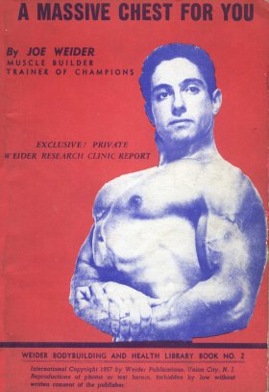

Exercises:
You will find here 29 basic exercises, along with a great number of variations. Each exercise will be numbered and you will be told exactly what the specific benefits of each are. In addition, I am breaking down the exercises into four major groups:
1) Barbell Exercises for the Front of the Chest
2) Dumbbell Exercises for the Front of the Chest
3) Barbell Exercises for the Upper Back
4) Dumbbell Exercises for the Upper Back
I am doing this purposely for two reasons. Later on, when I outline specific routines for your various chest aims, such as greater bulk, increased definition, a deeper rib box and so on, I will merely have to give the exercise number, list the sets, repetitions and other pertinent information, and you can refer back to this chapter to learn how the exercise is done.
My second reason for grouping the exercises in this manner is to assist you in your more advanced stages of training, possibly years from now, after you have tested and benefited from the information in this book and desire to arrange your own routines. You can always refer to this chapter and have a handy, perpetual guide for your future training. In this way you can double check your personal programs to make sure that they are the ones which will bring you the desired returns for your efforts.
Besides explaining the 29 basic exercises, I will also explain many variations of these basic movements and tell you what the specific purpose of each variation is. Sometimes the mere difference of a wide grip and a narrow one can produce an entirely different bodybuilding effect and if you know what such variations can do in your chest developing program you will naturally insure faster gains.

Group One -
BARBELL EXERCISES FOR THE FRONT OF THE CHEST
Exercise No. 1 - The Stiff Arm Pullover
The specific benefits of the stiff arm pullover are to deepen and widen the rib box. It contributes only slightly to the actual muscle mass of the front of the chest. However, it does tend to strengthen the upper attachments of the pectorals and in this way guards against too heavy, drooping pectorals. Pullovers of some sort should never be neglected in the chest program. This does not mean that you need perform pullovers every workout. However, from time to time you should include them in your workouts to assure maximum rib box growth.
The pullover is of particular benefit to the beginner in bodybuilding whose entire rib box formation is undoubtedly stunted in size. By increasing the depth and width of the rib box, he will step up the functional efficiency of the heart and in this way not only assist his chest building program, but his overall training success as well.
The usual method of performing the stiff arm pullover is to lie on a flat exercise bench, or else to raise the upper body off the ground on a stool. Then, hold the barbell with a shoulder width grip, palms facing to the front, the weight at full arms' length above the chest.
Take a deep breath and lower the weight to the rear. Lower as far as comfortable, or until a distinct binding is felt in the shoulder area. DO NOT force the weight down below that binding point. To do so, particularly in the preliminary stages of training could cause serious injury to the shoulders and might delay training for weeks, even months.
Always remember that in the human body, just as in any other delicate mechanism, nothing is ever gained by forcing. You can train the body to perform almost any physical feat, but you must coax it along in sensible stages to avoid damage.
Once the weight is lowered as far as is comfortable, it is pulled back to the starting position. The breath is exhaled while doing so. The entire movement is then repeated.
An even more elemental method of performing the pullover is to proceed exactly as explained above, but instead of doing the exercise either lying on a flat exercise bench or else with upper body raised on a stool, the entire movement is performed lying on the ground.
In cases of extreme muscular weakness, or when older men, those over 40, start bodybuilding, such a procedure is a safeguard against shoulder strain. However, even the weakest individual will soon outgrow the benefits of the floor version and he should progress to a more advanced one.
A simple method of progression is to place a pillow or a cushion under the upper back and this will raise the upper body off the floor and permit greater exercise freedom. After a few weeks, the flat bench or stool variety should be practiced and from that point on the floor version should never be gone back to.
A very close hand grip pulls more on the muscles under the armpits and loses much of its rib box effectiveness. It should only be used after the rib box is as deep as desired and if a more pronounced under arm development is needed. However, since there are better exercises for the under arm area, the regular, shoulder width hand spacing should be relied on in the stiff arm pullover.
A very wide hand spacing throws a greater strain on the shoulders, and is of little benefit to the rib box. This is not to be practiced if the most benefit is to be obtained from the stiff arm pullover.
However, there is one variety that will benefit the bodybuilder and one he should practice from time to time. This variety is as follows:
- Use about half the weight you can use in the regular stiff arm pullover. Start in the regular flat bench position, with weight at arms' length above the chest. Now, round your shoulders and reach up as high as possible. Hold your shoulders raised up in that position and continue to reach HIGH and then perform the pullover. This version throws a real strain on the hard-to-develop serratus magnus and should be practiced from time to time.
The stiff arm pullover can also be performed starting at the thighs and then, in a half circle, raise the weight first up and then to behind the head. This movement throws quite a lot of exercise stimulus on the lower section of the pectorals and is valuable for that. However, generally, the amount of weight that can be handled is less than in the regular pullover, which lessens its rib box development effect. If only the portion of the exercise from the thighs to arms' length above the chest is performed, then this version can assist in thickening the lower section of the pectorals. It is better to perform the pullover as one exercise and then reduce weight and perform the movement from the thighs to above the chest as a separate one; provided, of course, that specialization is needed on the lower pectorals.
Some authorities advocate the use of an incline bench for the stiff arm pullover. I am not in agreement since the angle of the bench throws most of the strain onto the deltoids and there is very little rib box stretching when the weight is above the head. In my estimation this is merely a secondary chest exercise and one that can well be done without in this course. It should not be overlooked for frontal deltoid development, however, and you can jot that version of the pullover down in your note book to be considered for deltoid development.
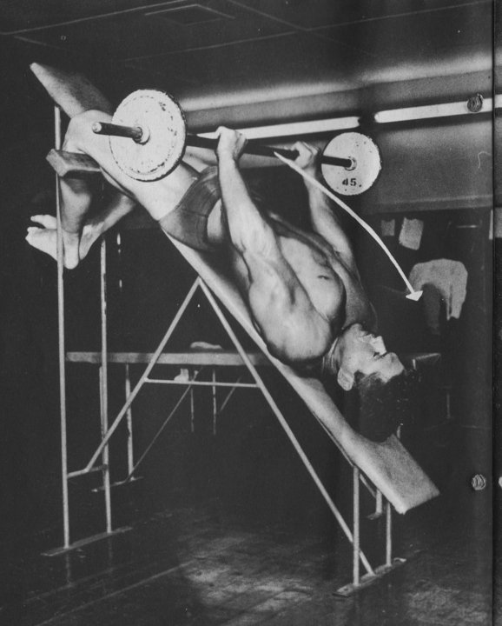

The DECLINE pullover is a valuable variety. A decline bench can be easily set up, using a seven foot length of 12" planking with one end raised on a sturdy box or bench and the other permitted to rest on the floor. The feet are positioned on the high end of the board and the head is toward the floor, or more expressly, the body is declined. If pullovers are performed in this manner, with the head, lower than the feet, an additional strain is thrown on the upper pectoral attachments and these then tend to pull the entire pectoral surface high. Not only does this assist in deepening the chest, but it imparts a high curve to the pectorals which is desirable.
After spending some time with the regular pullover, consider the decline pullover as a valuable variety you should not overlook.
Exercise No. 2 - The Bent Arm Pullover
The bent arm pullover is a cheating version of the regular stiff arm pullover. It is a more advanced style and throws greater strain on the pectorals as a whole. It is not to be practiced until after at least several months of training on the regular stiff arm pullover. If you employ the stiff arm pullover properly in your beginner's workouts, a few months will be sufficient to deepen and widen your chest appreciably. The bent arm pullover will continue this rib box growth, but at the same time it will add the element of extra pectoral muscle work.
Start with the weight resting on the chest, in about a line with the nipples. Use a normal, shoulder width hand spacing with the palms of the hands facing to the front.
Take a deep breath and raise the weight about four inches above the chest. Then, permit it to ride back down and as close to the head as possible until it reaches . . .
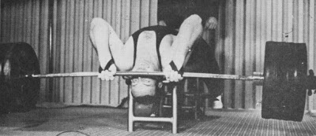
430 lb. Bent Arm Pullover

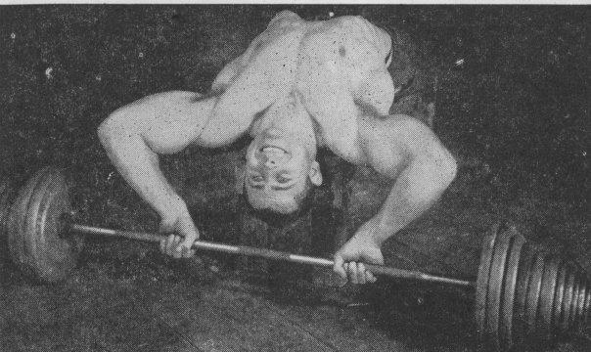

Okay then. Draw the weight back to the chest and exhale while doing so. Then repeat the entire movement.

A narrow grip in the bent arm pullover is preferred by certain lifters. Others perform it with the palms of the hands facing the rear. However, while such variations are undoubtedly interesting and if performed occasionally do tend to pep up a workout, they are merely novelty versions and do not influence the front of the chest as beneficially as the normal manner. Still, you should practice them from time to time, but always go back to the usual form for its proven worth.

A wide grip is not practical and in fact, difficult to practice. It is of questionable chest benefit and may quite readily be discounted as far as this work is concerned.

The incline version of the bent arm pullover is likewise an inferior chest movement, EXCEPT for the serratus magnus region. It will assist the formation of well defined serratus magnus and can be employed for that. But don't look at it as a means for increasing chest girth.

The major purpose of the bent arm pullover, performed in normal style is to CONTINUE the growth of the rib box and add appreciably to pectoral bulk, AFTER the stiff arm pullover has laid the basic groundwork, Do not jump over the stiff arm pullover and go into the bent arm version immediately. If you do, you will require a longer time than normal to stretch your rib box to its maximum size.

Exercise No. 3 - Rebound Bent Arm Pullover

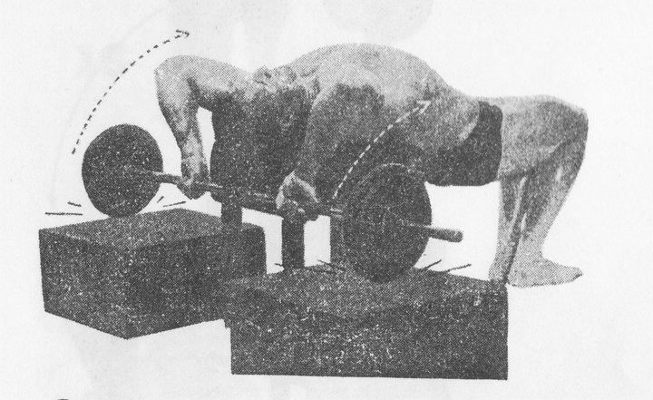
The rebound pullover is a POWER movement. Because you can use tremendous poundages in it, in a sense it will assist you to greater chest bulk. It is, however, a progression beyond the regular bent arm pullover, just as that exercise was a progression beyond the stiff arm pullover and should be relied on only for advanced training.
It is performed exactly the same as the regular bent arm pullover, except that two boxes are placed behind the exercise bench. The weight is then lowered onto these boxes, permitted to hit the boxes with some force and to rebound off them. The lifter gains control of the weight on the rebound and pulls it back to the starting position. A normal shoulder width hand spacing is used.
The major benefit of the rebound pullover is to get you past sticking points in the regular bent arm pullover. If you hit a period during which it is difficult for you to increase poundage on the regular bent arm pullover, a few weeks spent on the bent arm rebound version will so increase your power that the sticking point will be broken quickly.
As an extra dividend, the rebound pullover will help you to bulk up your chest, due to the heavy weight used. It might, however, tend to make you too beefy looking if followed as a regular diet. Therefore, employ it sensibly for short periods of time, either to break a sticking point or else to give you a lift in power, and rely on the regular bent arm pullover for general chest development.
Exercise No. 4 - Bench Press
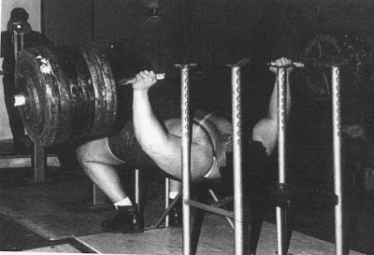

Pat Casey

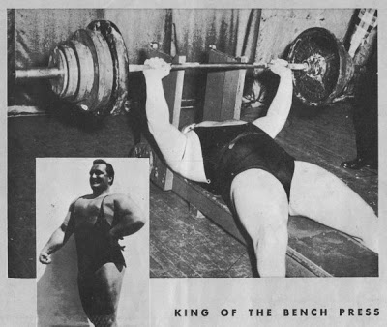

Doug Hepburn

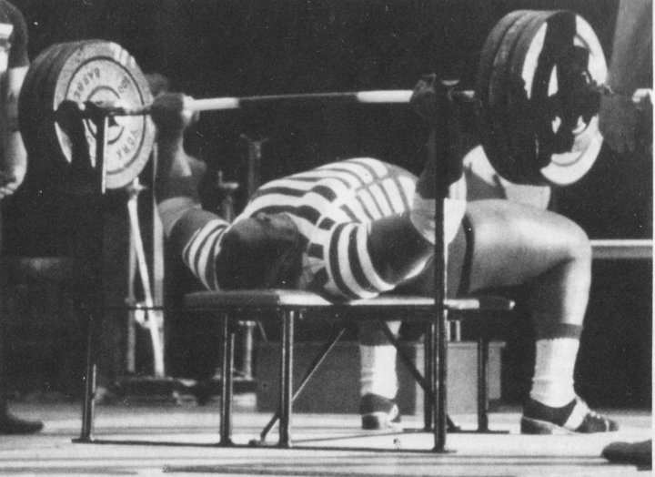

Jim Williams

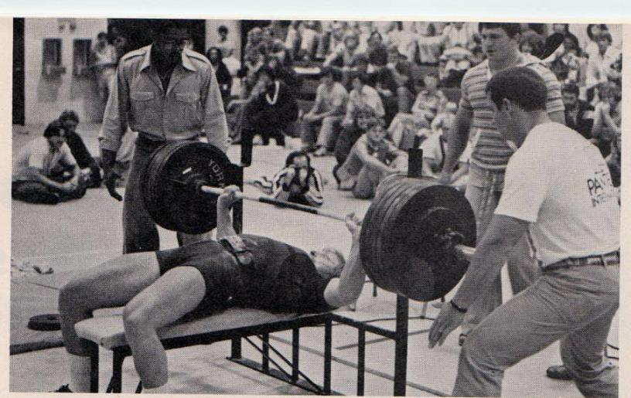

Mike MacDonald
A wide hand spacing influences the outer portions of the pectorals most. A shoulder width hand spacing affects the center mass area, shoulders and triceps more. A close hand spacing throws most of the strain on the triceps area, so much so that much of the chest benefit is lost and it is not advises as a chest movement.
For the purposes of chest development use either a wide or a shoulder width grip. Better still, vary the hand spacing from time to time to assure a fully rounded development of the pectorals.
Performing the bench press with palms of the hands facing the rear (reverse grip bench press) is more of a triceps exercise and deserves no attention in this particular book.
The incline bench press influences the upper section of the pectorals and the shoulders more than the regular bench press, and is a valuable variety.The decline bench press finds the weight difficult to control and apt to get out of hand, and therefore can be eliminated.
It is hard to improve upon perfection, so let us be satisfied in our knowledge that the bench press is undoubtedly the finest pectoral exercise in the world and not waste too much time in looking for variations.
Exercise No. 5 - Rebound Bench Press
Commence with the weight held at arms' length above the chest, either a wide or shoulder width hand spacing. Lower the weight quite quickly and permit it to rebound off two boxes. Regain control of the weight on the rebound and press it back to the starting position.
Because the barbell does not go down as far as in the regular bench press some of the pectoral action is lost. But, a few weeks on the rebound principle will so step up power that you will be able to handle much heavier weights with greater confidence, which will over time result in greater muscle bulk.
Use it to add variety to your training, or because you have hit a sticking point. Rely on the regular bench press to do most of the pectoral building for you. The rebound bench press will merely give you added power, as and when needed.
Exercise No. 6 - Special Serratus Magnus Exercise
This is a simple yet effective serratus magnus movement. Stand erect with a barbell held at the chest as in the regular two arm standing press. Now, raise the weight up until it just clears the head, take a deep breath and lower it behind the head. Pull the weight back to the starting position and repeat. You can use either a normal shoulder width grip, or else a rather close one in this exercise, and it is one of the best serratus magnus movements known.

Group two :

DUMBBELL EXERCISES FOR THE FRONT OF THE CHEST

Exercise No. 7 - Dumbbell Pullover on Bench

Identical in performance to the barbell pullover on bench. Some bodybuilders feel a greater pull in the rib box when the feet are raised and resting on the end of the bench. You can test both versions, either with feet on the floor or with them raised, and the one that gives you the greatest rib box stretch will undoubtedly be the best for you.

The barbell pullover can also be performed in this manner, with feet raised.

Exercise No. 8 - Alternate Stiff Arm Pullover

Start with both dumbbells above the chest as in the regular dumbbell pullover. Now, take a deep breath and lower one dumbbell to behind the head and the other to the thigh. Draw the weights back to the starting position, exhaling while doing so. Then, take another deep breath and lower the alternative dumbbell to behind the head and the other is lowered to the thigh. Draw the weights back to the starting position and repeat again.
This exercise will not only develop the rib box but can produce great depth to the lower pectorals particularly, PROVIDED you are one of those fortunate ones who is structurally built to benefit from it.
For those who do respond, the same exercise works well on an incline bench and on a decline bench. Form your final opinion after giving a month of so trial.
Exercise No. 9 - Bent Arm Pullover With One Dumbbell
This one's very well known. Can be performed on a flat exercise bench, or on an incline for more serratus magnus effect. It can be performed 'rebound style' for added power.
Exercise No. 10 - Regular Bent Arm Dumbbell Pullover
Same as with barbell, using two dumbbells.
Exercise No. 11 - Round The World
The exercise is started lying on a flat exercise bench with the dumbbells held at the thighs. From that position they are moved simultaneously off to the sides and circled around until they meet behind the head. The dumbbells are then pulled up, as in the pullover, and lowered back to the thighs.

Since this is a leverage exercise, it is best performed in cheating style, with the elbows slightly bent to reduce the strain on them.

Breathing is much a matter of preference. Some breathe in while circling the weights to behind the head and then exhale when lowering them to the thighs. Others prefer the opposite method of breathing. Still others take short, panting breaths and never inflate their lungs fully at any one time.

An incline bench version of this movement places such strong stress on the deltoids that they tire long before the pectorals receive much work, so as far as chest building is concerned it can be discounted.

The decline bench variety places great stress on the upper chest muscles and that style should not be overlooked.

Exercise No. 12 - Lying Lateral Raise

No explanation of the regular performance necessary.

To cheat, the starting position is the same, but as the dumbbells are lowered off to the sides, the elbows are bent until the forearms are at about 45 degrees to the upper arms, or halfway between being straight and at right angles with the upper arm. Then, when the weights are drawn back to the starting position, the arms are gradually straightened again. Performed in this style, tremendous poundages can be employed and the pectorals bulk up fast.

Performing this exercise on an incline is worthwhile and should be added to your routine from time to time.

Exercise No. 13 - Rebound Laterals

Use boxes to to lower the bells to and then rebound off of. Like all rebound exercises, this style of the lateral raise should be relied on mainly for breaking sticking points in this exercise and for building an increase in power.

Exercise No. 14 - Decline Laterals

Performed on a decline, lateral raises can strengthen the upper pectoral attachments and contribute to a fuller chest.

Exercise No. 15 - Dumbbell Bench Press

Because of the difficulty in controlling two separate weights, you cannot use as much combined weight in the dumbbell bench press as you can in the barbell style. However, it does educate the muscles to work in coordination and because of the greater flexibility of movement can produce extra growth. They can be performed on an incline or a decline, and the dumbbells version allows for a varying grip over the performance of the movement.

Part Three :
BARBELL EXERCISES FOR THE UPPER BACK
Exercise No. 16 - Standing Press Behind Neck
This exercise contributes a thickness and depth to the upper back muscles and the rear shoulders.
Start with the barbell held across the rear shoulders, and note that the hand spacing is considerably wider than shoulder width. It can be performed strictly, or in a cheating, 'push press' version.
Exercise No. 17 - Seated Press Behind Neck
In the standing version, the body position can be altered to some degree or shifted so as to ease the upper back strain, and the legs can be used to help push the weight at the beginning of the lift. In this seated version, such alteration of an upright stance or use of the legs is impossible, and the upper back and shoulders must bear the brunt of the work.
Even though you can cheat more in the standing version and handle heavier poundages, in the end the upper back receives just as much work in the seated style due to the more direct muscle action.
The standing version will build more all around power, however, and it is a good idea to practice both in your workouts, performing the standing version for a few weeks and then switching over to the seated.
Exercise No. 18 - Shrug
Can be performed strictly, with a short hold at the top position, or with large weights and some body motion to assist in the shrugging action.
Exercise No. 19 - Seated Upright Rowing
While the regular upright rowing is generally considered a direct shoulder exercise, when the seated style is employed it really can make the latissimus dorsi muscles work. No doubt the explanation is that, other than the different starting position of the seated version, the standing variety lends itself to swinging the body and helping lift the weight by lower back action. In the seated version no such body swing is possible, the exercise begins from a dead start, and the latissimus is forced to work harder, but -- being that the deltoids are the weaker muscle units, there is still enough work for them, so they are indeed influenced.
To perform the seated upright rowing exercise place a barbell across the thighs while seated on a flat exercise bench. Grasp the barbell with a very close grip, the palms of the hands facing the body. Next, pull the barbell up to under the chin. Lower to the starting position and start again from a dead stop.
Besides the narrow grip, you can practice with a shoulder width as well as a wide 'snatch grip' hand spacing, all with excellent results.
Exercise No. 20 - Bent Forward Rowing
What the bench press is to the front upper body muscles, bent forward rowing is to the upper back muscles. There are a number of varieties of the movement and all of them are superb. This exercise and the two following it will explain those which can be performed with a barbell.
The regular bent forward rowing exercise is performed as follows : Bend forward until your upper body is at right angles to your legs. Keep the knees stiff. Grasp a barbell at the floor with a normal shoulder width grip. The palms of the hands are facing the body. Raise the barbell a few inches off the floor by lifting the upper body slightly. The arms are to remain stiff while you do this. Next, maintaining this position strictly, pull he barbell up until the bar touches the chest around the nipple area. Lower the barbell to arms' length toward the floor again, but do not permit it to touch the floor and then repeat the movement again.
Besides the normal shoulder width hand spacing, a wide as well as a narrow grip can be used effectively. As you advance in your training and the weights get heavy in this exercise you may experience some strain on the lower back if you keep your knees stiff and locked. A good idea then is to bend the knees slightly, just enough to take the strain off the lower back.
To cheat in this exercise you employ considerable body motion, pulling up with your upper body to help your arms to get the weight started and then you snap the upper body downward so that your chest touches the bar at slightly lower than the starting position.
For power training you can employ the rebound principle, in which the barbell is either rebounded off two rubber pads on the floor, or else two boxes, which will be explained in the next exercise to follow.
Exercise No. 21 - Rebound Rowing
The plate ends of the bar are placed on two low boxes so the bar is at approximately a height below the knees. In this version the knees are bent quite a bit and the upper body is held much in the same position that it would be when performing the regular deadlift.
Now, with a combined pull of the upper body and power from the arms, the weight is raised toward the chest. The upper body is allowed to lower once the weight has gained some momentum and does so until the bar touches the chest. Then the weight is lowered and permitted to rebound off the boxes, control of the bar is regained and the weight is brought once again to the chest.
This exercise, like all rebound and partial movements is intended primarily for breaking sticking points in training and will serve that purpose best. Use a comfortable hand spacing, one which permits you to use the most weight.
Exercise No. 22 - End of Bench Rowing
This is a direct action upper back exercise intended for promoting 'isolation' more than for either power or size. Lie on a long, high exercise bench and grasp a barbell placed on the floor underneath. The palms of the hands are facing the rear and the hand spacing is about shoulder width. Slowly and with mental concentration pull the weight up until the bar touches the underside of the bench Then lower to the starting position without touching the floor and repeat. A wide grip works the upper back muscles in a different manner and should be employed from time to time.
Exercise No. 23 - Continental To Shoulders
More on the Continental Style Here:
http://ditillo2.blogspot.ca/2010/05/continental-cleans-for-overhead.html
http://ditillo2.blogspot.ca/2009/12/two-hands-continental-peary-rader.html
This is a real power builder, one which will give you a wide latissimus spread. To perform it properly you must affix a strong belt, one with a wide buckle, around your waist. You next lift a barbell from the ground and support it at your waist, upon the buckle of the belt. Next, bend the knees slightly and bend the body forward and now, briskly straighten the knees and snap the upper body back, pulling with the arms at the same time, and raise the weight to the shoulders where you hold it as you would for a regular standing barbell press.
Lower the weight back to the waist and repeat lifting it to the shoulders. An enormous amount of weight can be handled in this exercise and the latissimus dorsi are worked strenuously. This is a real advanced movement, and not intended for beginners. Do not confuse this with a 'pretty' movement. Grind and grit is what it's about here.
Exercise No. 24 - Kneeling Clean
This is a more direct latissimus movement than the previous exercise, but it is still a very advanced movement and will build all around power and a wide upper back. Start the exercise kneeling on the ground and grasping a weight with the palms of the hands facing the body. Now, straighten up the upper body and while doing so pull up and clean the weight to the shoulders. Lower to the starting position and repeat.
It is also possible to utilize the rebound principle, bouncing the barbell off the ground, once you have mastered the normal style. High level, long-talking, khaki-panted MFers have shown this movement to be inappropriate. What better recommendation do you need.

Group Four :

DUMBBELL EXERCISES FOR THE UPPER BACK
Exercise No. 25 - Bent Forward Laterals
While this exercise does not produce much bulk in the upper back, it does add to rear deltoid and upper back muscularity, imparting a more impressive upper back form. It can be performed with locked, straight arms or with a varying degree of bend at the elbows. It can be performed rather slowly with relatively lighter weights and with strong mental concentration, or with heavier weights and some swing and body motion.
Exercise No. 26 - High Bench Two Dumbbell Rowing
This if performed similar to the barbell version, and the rebound technique can be used here as well.
Exercise No. 27 - One Arm Rowing
Can be performed strictly, or not. Rebound can be used.
Exercise No. 28 - Dumbbell Shrugs
Same as above.
Exercise No. 29 - Side Press
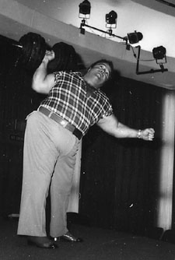

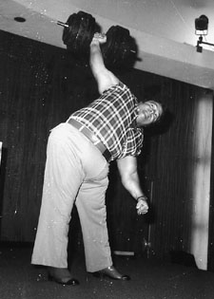

John Goodman Side Pressing on the set of Argo
This exercise can be an excellent latissimus builder. Regular use of it will add greater width to your upper back which will in turn ad inches to the measurement of your chest.
To perform the exercise stand erect, feet a comfortable distance apart, a dumbbell held at the shoulder. Bend over to the side and at the same time press the weight to arms' length above the head. DO NOT bend the knees when performing this exercise. Keep them locked. When the weight has been pressed to arms' length above the head, lower it to the shoulder and repeat.

Training for Bulk
In advanced training, whether this be for bulk, definition, or regardless of what the particular goal may be, the bodybuilder must stop thinking of exercises and exercise combinations as being his entire salvation.
More on this by the same author here:
http://ditillo2.blogspot.ca/2016/06/massive-arms-for-you-part-seven-joe.html
Instead, he must look at exercises as merely being a means of physical expression, and rely on variations in sets, repetitions, frequency of training, and actual exercise style as being even more important than the exercises he selects. These variations in sets, repetitions, etc., are termed 'basic principles'. From six months experience right up to the end of his training life, the bodybuilder will have to be constantly conscious of 'basic principles' if he is to reach his desired goals.
In training for bulk, almost any exercises can be made to do the job, PROVIDED the correct basic principles are followed. Just what are those basic principles. I will outline them now.
In a bulk program the most important is DIET. You cannot gain weight and bulk up your body if you do not supply it with adequate nutrition. The arrangement of your meals is important. To gain weight quickly you should be eating three substantial meals each day, and several in between meal snacks.
If breakfast finds you with a lack of appetite, you may be eating too soon after waking. Try getting up half an hour earlier in the morning if possible. Do your usual preparations first, take your time, and only after that time sit down to breakfast.
If you are unaccustomed to quite heavy eating don't simply force a great amount down at first. Gradually increase the quantities until you have reached the needed amount.
The mental approach is also important. You must be confident, relaxed and must avoid any nervous tension as much as possible.
Of course, REST is important.
Now for your exercise programs. When specializing on any body part or lift, the goal being specialized must receive more attention than any other training goals. To do this, you can follow one of two plans:
1) You can perform the specialization 'stuff' first [don't be intimidated by these scientific terms] in your routine when your energy is highest and then follow up with the 'stuff' for the rest of your body. When following this plan, once you have passed the beginner and intermediate stages of your playing, I mean training, your best method is to start off with the front chest exercises, then go to the upper back. Follow these exercises with the arms, waist, lower back, legs and finally the neck.

When following this first type of plan for bulk training you are to train 3 TIMES A WEEK, covering the entire body each time, but with special emphasis on the front chest and the upper back.
2) A better plan, and the one I recommend is the split method of training. To do this your perform your front chest and upper back exercises ONLY on two or three training days of the week. On two or three alternate days of the week you train the rest of your body, NOT INCLUDING the front chest and upper back.
Since most chest and upper back exercises influence the shoulders, there is no need to exercise them directly when on a specialized chest/upper back program. At a later date, once your chest has made substantial improvement, you can spend some time with direct shoulder exercises and bring them up to par if they have fallen behind. But generally speaking, by their very nature, front chest and upper back exercises, when specialized in, will automatically attend to your shoulder requirements.
The basic exercise principles that you should follow when bulking up are NOT to perform too many different exercises in any one routine. You can change your exercises from time to time and in that way assure the development of your muscles from all angles, but if you do too many different exercises for any one part in any single routine you will never reach your peak performance in the exercises and will hold back your gains. The absolute maximum number that you are to perform is 6 different exercises, 3 for the front chest and 3 for the upper back.
The repetitions are to be relatively low, from 5 to 8 repetitions a set, but you can safely work up to 5 sets of each exercise. DO NOT perform the exercises in too strict a style. Rather, cheat as much as necessary to force out the sets and repetitions when handling maximum poundages for the repetition counts.
Whether you are training three times a week on an all around routine or if you are following the split routine of training, confine the exercises for the rest of your body to ONE exercise for each major part. This will mean that besides the 6 front chest and upper back exercises (which is your absolute maximum) you are to perform 1 neck exercise, 1 biceps exercise, 1 for the triceps, 1 for the forearms, 1 for the waist, 1 for the lower back, 1 for the thighs, and 1 for the calves, adding up to a maximum total of 14 different exercises.
For the exercises for the other parts of your body, follow the same basic exercise principles that you do for the chest, which are LOW REPETITIONS, HEAVY WEIGHTS, UP TO 5 SETS OF EACH EXERCISE AND A CHEATING STYLE.
In this rather highly specialized form of training which is now being discussed, it is best to start off with your front chest muscles and then go on to the upper back. In the intermediate and beginner's routines, experience has indicated that it is better to perform the upper back exercises and then follow them with the chest. But, this pattern should be reversed once you are more advanced.
While six total chest and upper back exercises are your limit, this in no way means you need practice this number for bulk. In many instances the bodybuilder will do best with only two exercises, one for the front chest and one for the upper back. If he handles really heavy weights and cheats on the exercises, two really good movements might serve him best.
A sample grouping would be the barbell bench press, Exercise No. 4, and the barbell bent forward rowing, Exercise No. 20. Concentrating on these two exercises for a few months and making a real effort to handle limit poundages will often result in remarkable bulking up of the area.
Another grouping is the dumbbell bench press, exercise No. 15, and the one arm rowing, Exercise No. 27. In these exercises the dumbbells are made to perform the same duties that a barbell was in in the first set of exercises.
The observant reader will notice that in the two sample routines just listed the pectorals and the latissimus were given the work to do. And, for a good reason, of course. The pectorals and the latissimus add the most to the actual bulk of the front chest and the upper back, so any sensible bulk routine must not overlook this truth.
Using this as a key, the bodybuilder should now have no difficulty selecting other two-exercise combinations. The lying lateral raise, Exercise No. 12, and the kneeling clean, Exercise No. 24, can make up another example. The round the world exercise, Exercise No. 11, combined with the seated upright rowing, Exercise No. 19, makes another good 2-exercise pairing.
You will have little difficulty in arranging many combinations if you study the exercise chapter and review what each of the exercises listed can be used for.
With the actual exercises decided on, your method of performance comes next. Most bodybuilders will respond well by merely performing 5 sets of the front chest exercise, each set from 5 to 8 repetitions, with a short rest between sets and then after another short rest doing the same with the upper back exercises. They will merely use all the weight that they can and force out the repetitions by using a cheating style.
However, other bodybuilders will do best if they follow another style of forced repetitions training. They will perform the first 5 repetitions of each exercise as usual. Here they must use a weight that is so heavy that they simply cannot perform more than 5 repetitions regardless how much they cheat. Then, they should have a training partner who assists them is squeezing out a few extra repetitions. To do this, he merely places his hand under the weight and assists the bodybuilder to force out extra repetitions. The training partner is to supply just enough help to make the movement possible and, the bodybuilder must be forced to fight the weight every inch of the way.
A total of 8 repetitions a set is performed in this manner, 5 in regular cheating fashion and 3 more in this forced repetition style. Often, such a method can be used for a time to force growth into stubborn muscles after other methods have failed to do so.
Another method of training which will help many individuals build bulk is the super sets style of training. In practicing this, the bodybuilder performs one set of the first chest exercise he has selected. He then immediately performs a set of the upper back exercise. Then he goes back to the front chest exercise and continues to alternate between the two until the full number of sets is performed in each.
This method of training produces tremendous flushness and often makes exceptionally stubborn muscles grow when used at the appropriate time. There is another method of super sets that can be done when two front chest exercises and two upper back exercises are practiced in the same program and that will be explained later on.
A final method of bulk training is called the 'long pause' system. in this, the bodybuilder performs a set of his front chest exercise and then rests a full 5 minutes by the clock. After 5 minutes he performs another set. He continues to perform a set of the exercise and to rest a full 5 minutes before he performs another set until all 5 sets have been completed. Then, he does the same thing with his upper back exercise. This method of training is usually only practical when a maximum of two different exercises are performed, for obviously if more were done in the same workout the program would become impossibly long. The theory behind this method of training is that by forcing oneself to rest for such a long period of time between sets permits a certain amount more weight to be handled.
If following only two chest exercises, one for the front chest and one for the upper back, does not seem to produce the desired results over time or no longer is showing results, then the next step is use two for the front chest and two for the upper back.
If you decide to do this, then you can select two pectoral exercises if you wish and two latissimus exercises. Or, you can select one pectoral exercise, one rib box exercise, one latissimus exercise, and one for the trapezius, or rear of the shoulders.
Most practical, in my estimation, would be to select 4 exercises which influence different chest and upper back areas. However, I will list two routines which show how to select pectoral and upper back exercises only, and then two routines which will show how to select 4 exercises which affect 4 different general areas.
For pectoral and latissimus bulk specialization try these routines.
1) Barbell Bench Press, No. 4
2) Lying Lateral Raise, No. 12
3) Bent Forward Rowing Exercise, No. 20
4) End of Bench Rowing, No. 22
And now, for another similar routine for bulk using 4 exercises.
1) Dumbbell Bench Press, No. 15
2) Round the World Exercise, No. 11
3) One Arm Rowing Exercise, No. 27
4) Kneeling Cleans, No. 24
For affecting 4 different chest areas, try these.
1) Bench Press, No 4
2) Bent Arm Pullover, No 2
3) Barbell Bent Forward Rowing, No. 20
4) Shrug, No. 18
Here is another.
1) Dumbbell Bench Press, No. 15
2) Bent Arm Pullover With One Dumbbell, No. 9
3) Seated Upright Rowing, No. 19
4) Standing Press Behind Neck, No. 16
In following these exercises perform the usual 5 to 8 repetitions, use all the weight you can and perform the exercises in cheating style. You can also try the forced repetitions method explained previously. Or, the super sets method, but when doing this, if practicing 4 exercises, instead of only two, you alternate the 2 front chest exercises super sets style and then the 2 upper back exercises as super sets.
The final method of bulk specialization includes 6 exercises, 3 for the front chest an three for the upper back. Here too, you can either perform 3 for the pectorals and 3 for the latissimus, or you can split them up over exercises that affect different parts of the chest.
Here are some sample routines.
1) Bench Press, No 4
2) Lateral Raises, No. 12
3) Round the World Exercise, No. 11
4) Bent Forward Rowing, No. 20
5) Kneeling Clean, No. 24
6) One Arm Rowing, No. 27
1) Dumbbell Bench Press, No. 15
2) Round the World Exercise, No. 11
3) Barbell Bent Arm Pullover, No. 2
4) Seated Upright Rowing, No. 19
5) One Arm Rowing, No. 27
6) Shrug, No. 18
1) Barbell Bench Press, No. 4
2) Bent Arm Pullover, No. 2
3) Dumbbell Pullover With One Dumbbell, No. 9
4) One Arm Rowing, No. 27
5) Seated Press Behind Neck, No. 17
6) Bent Forward Laterals, No. 25
The three combinations listed will give you an idea of how to arrange routines when 6 exercises are used. Here too, you can make many alterations to suit yourself as long as you consult the exercise chapter to make sure that you are selecting exercises which will do the job you want from them.
You should use heavy weights, cheat our the repetitions and perform 5 to 8 repetitions, 5 sets of each exercise.
You can also employ forced repetitions. It is not practical to practice super sets when using more than 4 exercises, however. It is better to perform the exercises regular set series style when this many exercises are being used to build bulk.

Power Training
The basic principles of training for power are quite similar to those outlined for bulk training. The diet must be substantial, more than average rest and sleep should be obtained, workouts should not be taken more than three times a week for any particular body part, and the weights used should be heavy and the repetitions low.
If only a general step up in power is desired, and the bodybuilder has no desire to specialize only on setting poundage records, then he can combine power training with an all around course. This means that he can either train three times a week, starting off with his front chest and upper back exercises, and then follow these with exercises for the rest of his body. Or, he can follow the split routine style of training, performing his specializes exercises two or three times a week, only, and the rest of his body on two or three other days of the week.
The sets, repetitions, and concentrated attempts to use heavier and heavier weights as explained for bulk training should be used. Only the actual exercises will be different. Even here, the exercises will be much the same ones that were used for bulk training, but their method of performance will be altered.
Most important for the individual who is interested in increasing his power is to make sure that he handles very heavy weights. One way to do this is to employ bouncing or rebound exercises extensively. If this is done, the power-bodybuilder can work up to near fantastic poundages which strengthen ligaments, joints, muscle attachments, etc., adding tremendously to his power.
Not too many different exercises should be practiced in any one workout. If the front chest and upper back are being specialized on, then merely add one biceps exercise, one triceps exercise, one lower back exercise, one waist exercise, and one exercise for the thighs to round out your routine. If you add any more you are almost certain to go stale and that must naturally be avoided.
Rebound exercises for the biceps and triceps are explained in my book Massive Arms for You (elsewhere on this blog in its entirety). However, if you refer to back issues of Muscle Builder and Muscle power magazines you will see many rebound exercises for other parts of the body.
It is best to practice only two rebound exercises for the front chest and two for the upper back. A sample routine would be this:
1) Rebound Bench Press, No. 5
2) Rebound Lateral Raises, No. 13
3) Rebound Rowing, No. 21
4) Rebound Shrug -
this exercise is not listed but is performed the same as exercise No. 18, except that the barbell is rebounded off a flat exercise bench to permit the use of heavier weights.
Another sample routine:
1) Rebound Bent Arm Pullover, No. 3
2) Rebound Bent Arm Laterals, No. 13
3) Rebound One Arm Rowing
same as No. 27 except dumbbell is rebounded off the ground
4) Rebound End of Bench Rowing
same as No. 22 except barbell is rebounded off the floor
Many of the exercises listed in this course are suitable for rebound versions and with a little experimentation you can arrange many different routines.
The preceding advice applies to the bodybuilder who is seeking overall power increase. However, the lifter who desires 'all out' power and who may want to try to break some record, particularly in the bench press or press behind neck, which are about the only really competitive lifts included in this course, will have to follow another plan.
For all-out power, you can only train on one exercise at a time. And, you must remain on this particular exercise until you have reached a peak of your power in it.
You must conserve all of your energy for the exercise and not spend any on other physical activity.
I will use the bench press as an example. Here is the way to train for maximum power in that exercise. And what applies to the bench press applies to any other exercise you may ever decide to build maximum power in.
You must follow all the basic principles of bulk training as far as a substantial diet, rest, and peace of mind are concerned. In fact, you must not only possess peace of mind, but you must actually gear yourself up mentally to an utter contempt of heavy weights. DO NOT TOLERATE ANY MENTAL BLOCK. Do not feel that because you have only succeeded with a certain weight in the past that this means you cannot exceed it by 50, 100, or even more pounds. And do not be awed by the lifts of strength champions. Rather, be mentally sure that what they have done, you can do too. The fact that they have done it proves that it can be done. And, while proving that such a lift can be made, it in no way means that even more cannot be lifted. So, if more can be lifted, why not by you?
That is the attitude to strive for and it will pay off in big lifting dividends. And now for your training.
When training for all-out power you cannot set any definite schedules of sets, repetitions, poundages used, or frequency of training. You will have to rely on your experience and the knowledge of yourself to indicate when you should take a workout and what you should do.
Train only when absolutely fresh and practically raring to go. If you have a soft job, get a lot of rest and eat nourishing foods, you may feel like training every day. If you have a harder job to take care of, or if for some reason your energy can't stand daily training, you may do better training 5, 4, 3, 2 or even once a week! But -- if you don't feel fresh and full of energy at least one day a week and cannot take a very satisfying workout on that day, then there is something radically wrong which will have to be corrected before you can hope to reach your peak of power.
Generally speaking, training 3 times a week will suit most power-seeking bodybuilders best. Try that first and then if you feel you should, you can experiment with other frequencies.
Now, here is exactly what you should do, and remember we are using the bench press as an example. This same plan can be used for any exercise.
Warm up with about one half of your maximum weight and perform 3 or 4 easy repetitions. Take a short rest and add 15 or 20 pounds. Perform 2 or 3 repetitions. Take another short rest, add some more weight and perform another 2 repetitions. Your muscles should now be warmed up.
Take a slightly longer rest and then add some more weight and perform 1 repetition. Another rest, another adding of weight and then another single repetition. Continue doing this, adding only 5 pounds at a time as you approach your limit. Continue to force out a single repetition with each increased weight until you fail to squeeze out even on repetition. Then, take a 10 minute rest and try that same weight, the one you failed with, again. Whether you make it or not, drop the weight down 30 or 40 pounds and perform as many repetitions as you can with this lighter weight. It probably won't be more than 3 or 4. Then, quit.
And, don't take another workout until you really feel full of energy. You follow the same procedure the next workout and keep following this plan indefinitely. However, you can only force power into any set of muscles in a concentrated manner such as this for about two months. After a two month period, it is better to go back to a rather general program, or if you so desire, you can pack power into some other major body part. Then, you can come back to the bench press again after such a rest and push your record up once more.

Training for Definition

In the training for an increase in muscularity or definition of the front chest and upper back area, certain basic principles must be followed, just as was true of bulk training.
Diet, daily activity, mental approach and the actual exercise practices must all be considered. We will delve into these basic principles now.
Diet: The bodybuilder striving for greater muscularity may or may not be overweight. He may merely lack hard muscular definement, and may not actually carry excess bodyweight. All he really wants to do is to harden up without any radical alteration of physical girths.
Or -- he may actually be overweight and may desire to lose excess size from certain parts of his body while he is hardening up.
Each of these two aims require specific dietary approaches . The actual exercise routines and the other basic principles will be consistent, but diet for each is a separate issue.
Let us take the man who is overweight first.
He MUST subsist on the lowest amount of daily calories which will support good health until his bodyweight is brought down to the point where he feels it should be. If he obtains satisfactory nutrition, he can lose weight quickly without endangering his health. However, if he merely cuts down on food intake and relies on a form of starvation to help him to lose weight, then he could end up with a nutritional deficiency which could prove even more serious than his original overweight was.
Most important in any reducing diet is protein, vitamins and minerals. BUT -- starches and fats must not be completely eliminated. A small quantity of each are needed daily to support good health.
Therefore, even while on a reducing diet, you should make certain that you are following a well rounded one. A sample daily menu follows:
For breakfast, one of the following -- half a grapefruit, one orange, or a 6 oz. glass of the juice of either. Then, one of the following -- a serving of a cooked or cold whole grain cereal with a moderate amount of milk, or -- a poached or boiled egg and two strips of well done bacon. And -- one slice of whole wheat bread either toasted or plain and a half a pat of butter. THAT IS ALL!
Lunch should consist of a salad plate consisting of all the celery, lettuce, endive, parsley, raw cabbage, carrot strips, etc., that you want. You can add a small helping of cheese, or a slice of lean meat, either ham or beef. One slice of whole wheat bread, a half a pat of butter and a 6 oz. glass of milk should round out the meal.
For supper you can be a bit more generous. A cup of meat broth, a serving of lean meat, fish or fowl, a cooked green vegetable, a baked potato with a small pat of butter, a raw vegetable salad, one slice of whole wheat bread with half a pat of butter, a glass of milk and a VERY SMALL serving of dessert, preferably stewed fruit sweetened with honey or brown sugar.
Between meals, NOTHING!
In addition to the above, be moderate with your intake of water. 6 glasses of water daily, in addition to the milk and other liquids of your diet will supply all the water you need.
Such a diet, if persisted in, is good for the health and will help you to lose weight quickly.
Now, if you are not overweight, but merely desire to harden up, you can be more lenient with your diet. All you need to do is to eat as much as you desire of fresh fruits and vegetables, lean meats, eggs, fish and fowl, whole grain products and to partake sparingly of potatoes, bananas, sweets and starchy or fatty foods. You can drink a little more milk and water, but not too much so. Rely on proteins, fresh fruits, vegetables and whole grain products for your major nourishment and eat sparingly of starches and fats. If you follow this plan, the fleshy tissue on your body will soon be replaced by hard muscular form.
Daily Activity
The bodybuilder who desires to bulk up should take it easy when not training. The bodybuilder who wants to become more defined should be physically active, even when not training. This does not mean that he should participate in exhausting sports when not training, but he should get more general exercise such a walking more, working around the house and garden, etc. In other words, in addition to his actual workouts, he should lead a physically vigorous life. This extra activity will help him to harden up.
He should not skimp on sleep. He must, for the sake of his health, obtain all that he needs nightly. But -- once he awakens in the morning, he should try to get up and should not remain in bed longer than actually needed for sleep. 8 hours a night is a good average. Less could be harmful and more could defeat his aim for greater muscularity.
Mental Approach
Just as his daily physical activity should be of a vigorous nature, the mental approach of the bodybuilder who is anxious to obtain greater muscular definement should also be vigorous. He should maintain an alive and active viewpoint. He should be confident, sure of himself, unafraid to tackle any job. In this way, he mentally attunes himself to a success drive that will help him to achieve his developmental aims.
Exercise Principles
The bodybuilder anxious to obtain greater definition will have to be willing to train his entire body 5 times a week. He is to start off with the exercises for his front chest, proceed to those for his upper back, and then he should follow the same method of exercise arrangement as explained for the bodybuilder who desires bulk and who trains his entire body 3 days a week. However, while the bodybuilder who desires bulk must not train any part of his body more often than 3 times a week, the definition-minded bodybuilder must train 5 times a week.
He is to perform 5 sets of each exercise, from 12 to 15 repetitions a set. The exercise style must be very strict and he is not to cheat in the exercises. He must pump out the repetitions at a moderate tempo and employ mental concentration while doing so, mentally contracting the muscles as he is exercising them.
Since added definition will depend mainly on harder muscular form, as far as the front chest is concerned, there is little use in wasting time on direct rib box exercises. It is best to confine your exercise efforts to the pectoral and serratus magnus muscles. However, in the upper back, all areas should be worked.
A good definition routine will consist of between 6 to 8 chest exercises, or 3 to 4 exercises for the pectorals and 3 to 4 exercises for the upper back, adding up to a maximum of 8 exercises in all.
Round out your routine with one neck exercise, two biceps exercises, two triceps exercises, one forearm exercise, one lower back exercise, three waist exercises, two thigh exercises and one calf exercise. Perform all these exercises for 3 sets, from 12 to 15 repetitions a set and follow the same strict style of training for these that you do with your chest exercises.
And now, here are a few sample chest routines.
1) Bench Press, No. 4
2) Special Elbow Raised Serratus Exercise, No. 6
3) Round the World Exercise, No. 11
4) Seated Press Behind Neck, No. 17
5) End of Bench Rowing, No. 22
6) Dumbbell Shrugs, No. 28
Another Sample Routine:
1) Dumbbell Bench Press, No. 15
2) Lateral Raise, No. 12
3) Special Serratus Raise, No. 6
using a pair of dumbbells instead of a barbell
4) Seated Upright Rowing, No. 19
5) End of Bench Rowing, No. 22
6) Side Press, No. 29
And now for a few routines in which 8 exercises are used.
1) Dumbbell Bench Press, No. 15
2) Round the World Exercise, No. 11
3) Elbow Raised Special Serratus Exercise, No. 6
4) Lateral Raise, No. 12
5) Seated Press Behind Neck, No. 17
6) One Arm Rowing, No. 27
7) Bent Forward Laterals, No. 25
8) Dumbbell Shrugs, No. 28
And a final one:
1) Bench Press, No. 4
2) Dumbbell Bench Press, No. 15
3) Lateral Raise, No. 12
4) Round the World Exercise, No. 11
5) Side Press, No. 29
6) Seated Press Behind Neck, No. 17
7) Seated Upright Rowing, No. 19
8) End of Bench Rowing, No. 22
There are many combinations possible. You can stress the pectorals and latissimus entirely, or else you can include the serratus and other upper back muscles, as you wish. But keep the exercises direct, keep the exercise style strict, train with mental concentration and employ high repetitions and a rather high number of sets.
It is not wise to attempt to use super sets, forced repetitions of other bulk principles when training for definition. Your best plan is to follow the method of training just outlined and to rely on diet and severe physical work to burn off the excess and to reveal the hard muscularity of your body.

