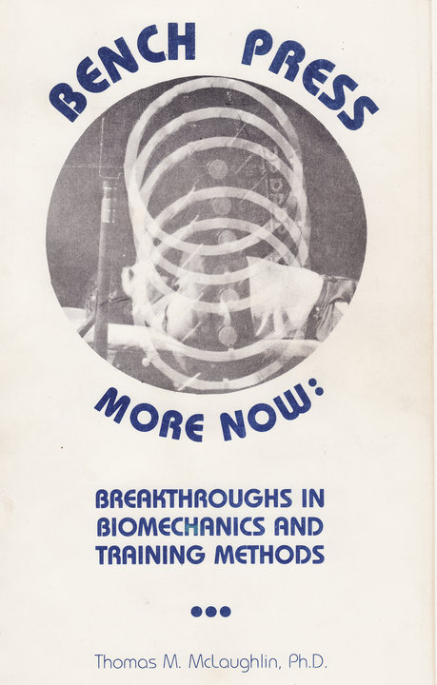
Contents

Chapter One: What’s So Interesting About the Bench Press
1.1 – A brief history of the bench press.
1.2 – Its widespread popularity.
1.3 – Current world records.
1.4 – Research on the bench press to date.
1.5 – The purpose of this book.
1.6 – How to use this book to increase your bench press.

Chapter Two: Biomechanics of the Bench Press
2.1 – The rules of bench pressing.
2.2 – Typical bar velocity and acceleration patterns.
2.3 – The degree of control used in lowering the bar.
2.4 – Forces exerted on the bar in the bench press.
2.5 – The sticking point.
2.6 – Horizontal position of the bar path relative to shoulders.
2.7 – The sequence of bar movements used in raising the bar.
2.8 – Grip spacing.
2.9 – Angling of the arms.
2.10 – Torques about the shoulder.
2.11 – Changes over time in top bench pressers.
2.12 – The “pause” in competition.
2.13 – Arching/bridging/bouncing.
2.14 – Hand/finger orientation in holding the bar.
2.15 – Symmetrical loading of the bar.
2.16 – What if you miss?
2.17 – Power output.
2.18 – Relationship of bench press capacity to bodyweight.
2.19 – Importance of chest size.

Chapter Three: Developing the Key Muscles Used in Benching
3.1 – What we know about muscle involvement in the bench.
3.2 – Training the chest.
3.3. – Training the triceps.
3.4 – Training the shoulders.
3.5 – Training associated muscles.

Chapter Four: Training Ideas for Developing a Bigger Bench
4.1 – General philosophy.
4.2 – Optimal training for key bench press muscles.
4.3 – Technique training for the bench.
4.4 – The “total” bench press training program.

Chapter One: What’s So Interesting About the Bench Press

1-1 – A Brief History of the Bench Press

In recent years the bench press has become probably the single most widely used weight training exercise. A considerable amount of weight can be lifted in this movement. World record lifts of up to 2942 N (661 pounds, note: 1 lb. = 4.45 N) have been set and lifts of over 1335 N (300 pounds) are not uncommon in even high school age individuals. Performance of the bench press involves initially taking a barbell at arms’ length while lying on a bench, and then lowering the bar to the chest. After a momentary touch at the chest the bar is then pushed back up until the arms are again fully extended.

Although barbell and dumbell lifting first became significantly popular in he late 1800’s and early 1900’s, at that time the bench press was almost completely unknown as an exercise. This exercise also appears very rarely in the books and magazines from that period on, and it was never done either as a competitive lift or as part of the presentation in strong acts in the circus or on stage.

Following the Second World War, however, its popularity sky-rocketed due to several factors, among which are the comfort during execution and the overall developmental qualities for the upper body. Its growth has continued to the present to the point where it is now generally considered by far the most frequently used of any weight training exercise.

In recent years the public has increasingly been made aware through the media of the value of weight training to general fitness, athletic sports of all types, rehabilitation, etc., by, for example, Olympic television coverage of East German and Russian training methods, etc. The importance of upper body strength in non-contact sports has even received a strong recent emphasis. In other words, it is now deemed necessary for a jogger or distance runner to have good upper body strength in addition to well-conditioned lower extremities. Additionally, competitive and recreational athletes have turned to weight training programs to develop upper extremity strength and endurance. Thus, almost any weight lifting program at present includes or centers around the bench press as a primary lift and developer of the chest and upper extremities.

1-2 – Its Widespread Popularity

At least four major groups can be identified that are interested in the bench press:

First, the practice of using weight training as an integral part of an athlete’s preparation has become increasingly common. The bench press has become one of the principal exercises used in developing upper body strength. Indeed, performance in this lift has even become important in some sports (especially football) as a fitness measure for recruiting, publicity, etc.

A second group consists of the ever increasing number of bodybuilders and recreational weight trainers among the general public. Although these individuals lift primarily for enjoyment and to maintain and increase fitness, their interest in performance and safety is undeniable. A tour of any gym or health spa will typically indicate more people bench pressing than doing any other exercise. Again, the lift is VERY comfortable and reasonably heavy weights can be lifted. It’s interesting to note that among the general population the question typically asked of a person known to lift weights used to be “How much can you press?”. Today it has frequently been replaced with “How much can you bench press?”. Indeed, bench press competitions (where only the bench press is contested) have become increasingly popular in recent years.

The bench press is also one of the three events that comprise he popular international sport of Powerlifting. The numerous participants in this sport are certainly interested both in improving their bench press performance and reducing their probability of injury from training this lift.

Finally, the sports medicine community has expressed interest in recent years regarding injuries, both chronic and acute, associated with the bench press. A better understanding of the bench press would provide useful information regarding both injury mechanisms and prevention.

1-3 – Current Bench Press World Records

For interest’s sake, the men’s and women’s current world records in the competitive bench press (performed under the rules of the International Powerlifting Federation) are:

Women’s World Records (as of March, 1984 - PLUSA)
097 – 165.0
105 – 180.4
114 – 184.8
123 – 228.8
132 – 213.4
148 – 231.0
165 – 308.0
181 – 330.0
198 – 264.0
SHY – 286.0

Men’s IPF Records (as of April, 1984 – PLUSA)
114 – 322.3
123 – 324.5
132 – 396.0
148 – 426.8
165 – 478.5
181 – 528.0
198 – 561.0
220 – 575.3
275 – 612.7
SHY – 661.0

1.4 – Research On The Bench Press To Date

Despite the widespread use of the bench press, there are no studies reported in the literature (as of the writing of this book) that have analyzed the bench press as an upper body strength building motion. Only studies related to the function of some of the muscles involved in bench pressing have been reported. For example, Rosentwieg, etal. (10) Have reported on a study of isokinetic bench pressing using electromyography with a sub-set of the muscles crossing the glenohumeral joint (deltoids, biceps, triceps, and pectoralis major). Jonsson and Jonsson (4) looked at a totally different sub-set of muscles crossing the joint in relation to driving (supraspinatus, infraspinatus, teres major, and teres minor). Deluca and Forest (3) reported on a model for predicting the muscle loads for a subset of muscles involved in abduction. There are also a number of papers (1, 2, 5) that present the function of some of the muscles involved with the glenohumeral articulation. Overall, however, no direct biomechanical or electromyographical studies of bench pressing with weights exist.

Due to the lack of literature on bench pressing, a group of us began several years ago at Auburn University to fully investigate the bench press movement. The research team consisted of the author, Nels Madsen, Ph.D. (Department of Mechanical Engineering at Auburn University) and Bill McLeod, Ph.D. (Bioengineer and Director of Research, Hughston Orthopedic Clinic, Columbus, Georgia).

The three major research goals that we were working toward were to find:
1.) How best to perform the bench press to optimize a lifter’s muscular force potential.
2.) How the lift should be performed to best work individual upper body muscles of importance to the lifter, orthopedist, or therapist, and
3.) What stresses are placed on the body (particularly the shoulder) in the lift, and how these can be minimized to allow safer lifting.

To date, we have made some progress toward all three lines of our research, but as yet we have only published or presented a few of our findings (6, 7, 9).

So far, about 120 bench trials of National and World class powerlifters recorded on high speed cinematographic film collected at the 1974, 1978, and 1978 U.S. Senior Nationals, 1979 Worlds, and the 1980 World Series have been subjected to 2D or 3D biomechanical analysis. An additional 40 film trials of beginners and intermediates, along with lab studies (using high speed 3D film analysis with synchronous EMG ‘muscle’ monitoring) of the current World Superheavyweight bench press champion and others have also been analyzed.

Comparison of Bench Press Techniques of Novices and Elite Powerlifters

The first major study, Madsen and McLaughlin (7), was designed to learn enough about the bench press to be able to propose testable hypotheses about its performance. The goal was to build a foundation for future research on the bench press. Of primary concern was the identification of kinematic factors that might be relevant to performance and injury risk in the bench press. Also of interest was the identification of any fine structure that might exist in the kinematics and kinetics of the bar movement.

To investigate the bench press, a study of the kinematics and kinetics of the bar was performed. Although the arm movements in the bench press are three-dimensional in nature, the end of the bar moves in a plane. A study of the two-dimensional motion of the bar was deemed appropriate as a starting point for research. In light of the fact that the objective of the bench press is to raise the bar, the characteristics of the motion of the bar must be understood before an investigation of the underlying phenomena can be begun Ultimately, three-dimensional studies will be required, and have been initiated (6).

High-speed two-dimensional cinematographic procedures were utilized to record the performance of 19 world-class powerlifters proficient in bench pressing while competing at the 1978 and 1979 U.S. Senior National Powerlifting Championships, the 1979 World Powerlifting Championships, and the 1980 World Series. Each world-class powerlifter was ranked in the top three in the world in the bench press at the time of his lift. Top bench pressers from the ranks of Powerlifting who were subjects included Bridges, Wright, Franz, Rafael, Bradley, Crain, Gant, Pacifico, Gaugler, Estep, Sideris, Woods, Thomas, Hatfield, Wilson, Anello, etc. An additional 17 “novices” (average training time on the bench press was 10.2 months) were also filmed under similar conditions. Biomechanical film reduction and analysis techniques were used to investigate the barbell motion characteristics of all subject from a side view (see (7) for more details).

The analysis revealed a number of important characteristics of the performance of champion bench-pressers (which will be discussed in detail in subsequent chapters). First, they clearly minimized the bar’s vertical acceleration while lowering the bar (average peak acceleration typically less than 1 m/s/s). Second, there were significant differences in the geometry of the sequence of movements used the high-skilled lifters versus the novices. It was found that this especially involved the magnitudes of the horizontal components of the motion of the bar during the lift (experts used a bar path closer to the shoulders) and in several key angles describing the bar’s path. Third, the high-skilled lifters were found to have less difficulty with the “sticking point” period of the bench press lift than the beginners. There was also no significant difference in torque required at the shoulder.

It was evident that the high-skilled bench pressers had over time adopted a common pattern of bar motion. The existence of this unique pattern is clearly evident from the results of this study and significantly differs from the “novice” patterns. The horizontal and geometric alterations in technique that the world-class lifters have adopted have a number of theoretical advantages over beginner or classically recommended techniques. The results of this study also have important implications regarding training procedures and potential injury mechanisms for anyone using the bench press as a weight-training exercise.

Bench Press Techniques of Elite Heavyweight Powerlifters

Since the first major study had compared the techniques of novice and world class powerlifters of similar bodyweight (bodyweights had to be in range of 130 lb. to 225 lb., mean for novices was 169.9 lb. and for experts was 174.2 lbs.), it was of interest to further investigate the bench press techniques of elite heavyweight powerlifters (see (9)). The film trials of 9 world class powerlifters (3 each from 242, 275, and superheavyweight classes) were selected for analysis. The weight lifted had to rank within the top 10 bench presses in the world at the time of the lift. Top lifters selected as subjects were Cole, Patterson, Wilson, Waddington, Kazmaier, Kenady, Wrenn, Young, and Iams. Trials were further selected so that the bench weights used by all 9 subjects were roughly equivalent (ranging between only 518 and 540 lbs., average 527.9 lbs.). Similar biomechanical film reduction and analysis techniques to (7) were used to analyze the selected lifts.

In general, the trends in performance demonstrated by the elite heavyweight powerlifters were very similar to what was reported in (7) for light expert powerlifters contrasted with light novices. The force applied to the bar at key points in the bench press followed a similar trend, the sequence of movements used were much the same for both expert groups, and the degree of control in lowering the bar was similar. Overall, the majority of observations reported in (7) that characterize skilled bench pressing were replicated here despite the increased bodyweight and size of this study’s subjects. However, power outputs were greater for heavy subjects. Also, perhaps the most important result was that torques about the shoulder can be expected to be larger for bigger athletes in the bench press. There may be a need for possible extra training of the shoulder musculature or greater emphasis on technique (horizontal bar path position, etc.) to help accommodate these higher torques. These results (from (9) ) will be fully discussed later.

Related Three-Dimensional, Electromyographic Studies

A three-dimensional electromyographic study (6) was conducted to explore, among other topics, the optimal style of bench pressing. More sophisticated laboratory analyses using 3D cinematographic kinematics, electromyography, and musculoskeletal modeling procedures were performed to contrast the technique of high and less-skilled subjects. Results showed existence of a “groove”, or path, that provides maximal performance by permitting optimal muscle involvement and sequencing (particularly pectoralis major, anterior deltoid, and triceps). Furthermore, such changes in technique are reflected in corresponding alterations in joint constraint forces, with potential bearing on injury mechanisms. There results will be discussed further in subsequent sections.

Two other studies were conducted to further explore the muscle load sharing in bench pressing. In the first (unpublished data), the current World Superheavyweight bench press record holder (Kazmaier) was filmed with simultaneous EMG records for key upper body muscles. He then performed a large variety of different types of bench presses (varying either grip spacing, where the bar hit the chest, speed of lowering , angling of arms, etc.) Results are discussed later. The second study (8) also investigated the EMG activity simultaneously with 2D cinematographic analysis of regular bench presses versus incline bench pressing at different angles of incline. Results will also be discussed in subsequent sections.

References
(1) Bearn, J.G., “An electromyographic study of the trapezius, deltoid, pectoralis major, biceps and triceps during status loading of the upper limb”, Anat Record , Vol. 140: 103-108, 1961.

(2.) Broome, H.L. and Basmajian, J.V., “The function of the teres major muscle: An electromyographic study”, Anat Record, Vol. 170: 309-310, 1971.

(3.) Deluca, C.J. and Forest, W.T., “Force analysis of individual muscles acting simultaneously on the shoulder joint during isometric abduction”, J. Biomechanics, 385-393, 1973.

(4.) Jonsson, S. and Jonsson, B., “Function of the muscles of the upper limb in car driving. V: The supraspinatus, infraspinatus, teres minor and teres major”, Ergonomics, Vol. 19, No. 6: 711-717.

(5.) Jonsson, B. Olofsson, B.M., and Stettner, L.C., “Functions of the teres major, latissimus dorsi and pectoralis major muscles”, Acta Morphol Neerl Scan, Vol. 9” 275-280, 1972.

(6.) Madsen, N. and McLaughlin, T.N., “Influence of three-dimensional geometry on success in the bench press”, Abstracts – J. Biomechanics, 1982.

(7.) Madsen, N. and McLaughlin, T.N., “Kinematic factors affecting performance and injury risk in the bench press exercise”, Medicine and Science in Sports and Exercise, Vol. 16, No. 4: 376-381, 1984.

(8.) McLaughlin, T.M., Garhammer, J., and Madsen, N., “Biomechanical analysis of a multi-station weight training apparatus”, Unpublished research report, Diversified Products Corporation, 1980.

(9.) McLaughlin, T.M. and Madsen, N., “Bench press technique of elite heavyweight powerlifters”, National Strength and Conditioning Association Journal, Aug-Sept, 44, 62-65, 1984.

(10.) Rosentswieg, J., Hinson, M., Ridgeway, M., “Electromyographic comparison of an isokinetic bench press performed at three speeds”, Research Quarterly, Vol. 46, No. 4: 471-475, Dec. 1975.

1.5 – The Purpose of This Book

With the already vast number and variety of weight training and fitness programs in the U.S. still growing daily, it has become difficult (to say the least) for anyone to effectively discover the proper technique and training principles for developing muscle size, strength and power. With the boom in popularity of weight training in recent years has come an avalanche of new “experts” on weight training, most of whom have no scientific background or often even any significant experience in weight training. Unfortunately, the misinformation generated by such individuals in books, newspapers, popular magazines, television, cable, etc. further distorts the facts. What adds to the confusion is that if an individual follows even the most poorly designed weight training program some results typically will occur. However, progress is typically short-lived as the consequences of poor exercise selection, techniques and program design are eventually felt.

Only through a blend of science and practical experience in weight training can advanced, productive weight training programs be effectively created, evaluated and disseminated. My goal in this book is to attempt to bring science and experience together, at least as far as one exercise, the bench press, is concerned. What I have attempted to do is combine approximately five years of research on this lift with the practical experience I have gained training on this lift for the last 15 years. I’m not personally a world record holder in the bench press, but am reasonably proficient, having gone over 500 lbs. in training. Fortunately, my insights on the practical side have been supplemented by my experiences training with top lifters like Bill Kazmaier, Bill Davis, Lars Hedlund, and many other top bench pressers and elite powerlifters that I’ve come in contact with via the National Strength Research Center, etc. I have also met a great number of top lifters over the years at meets, etc. and have acquired training ideas and concepts from most of these “practical” researchers of our era. Hopefully, I will be able in this book to blend this practical base with the scientific results of our research on the bench press.

By no means should the contents of this book be considered the “final word” on bench press techniques and training principles. Far from it. As a wise man said long ago, “The more I learn the more I realize how little I know.” Indeed, I have resisted the urge to write this book for several years now because I felt (no doubt from my academic background) that I did not have enough information to satisfactorily answer all of the questions I had about bench pressing. However, I have come to realize that this “state-of-the-art” sort of book may still be of value. Hopefully, it will. I fully realize, and you should also, that some of the ideas I present are not yet fully supported by objective, scientifically-valid research. The vast majority are, but to piece together the whole picture I have obviously had to tap my practical and intuitive insights where necessary. I have, however, attempted to keep you aware of what is fact versus what is supposition throughout the text.

There is a LOT to the bench press, as I hope you’ll see in the coming pages. Technique is absolutely critical to success in this lift. Training for this lift is equally sophisticated, partially due to the complexity of the shoulder joint (the most complex joint in the human body) as well as the muscles that cross it. It’s an intriguing lift that continues to fascinate me both academically and personally. Discovering the “optimal” techniques and training methods for improving this lift has become an exciting journey for me. I hope that the contents of this book will be of similar interest to you and perhaps stimulate you to personally investigate (either “practically” or scientifically) this lift even further. Who knows, maybe one of us will someday bench press a world record, of help someone else to do so!

1-6 – How to Use This Book to Increase Your Bench Press

The most important part of this book is the next chapter, on biomechanics. As I’ve said, technique is everything in the bench press! Be sure to go through this chapter carefully. I’m convinced it will be well worth your effort. The next most important chapter is chapter 3, on training methods, which also has a lot of valuable information. Concentrate on these two chapters and you’ll be well versed in bench press techniques and training theory.

I would then suggest that you read Chapter 4 and evaluate where you are now and where you’d like to be. Design a six month or year long training plan. Select the technique changes and the training concepts that you want to implement in your workouts and do so. This book can then serve as a reference for helping you if your progress in bench pressing should slow down for some reason. Finally, consider this book a “starting point” for the development of your own optimal training program. Don’t be afraid to experiment, within reason. We are all still individuals with different structures, recovery rates from training, etc. Learn what works best for YOU! After all, isn’t the greatest joy in weight training the feel of success when a routine you designed works well? Even in the age of pharmaceutical aids, how well you train is still the ultimate key to success.

Well, let’s get to the bench press!

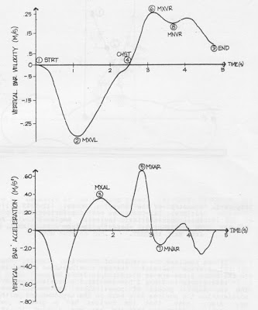

Figure 1. Typical Vertical Bar Movement with identification of Instants Used in Quantifying Bench Press. See text for further description of these instants.

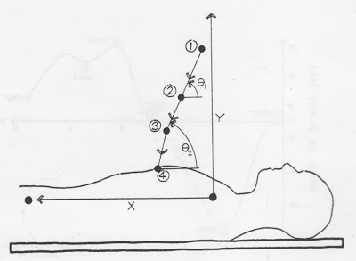

Figure 2.Geometry of the Lowering Phase. (1) = STRT, (2) = MXVL, (3) = MXAL, (4) = CHST; see text for further description of these characteristic instants. Angles are with respect to horizontal, where 1 (circled) is from STRT to MXVL, 2 (circled) is from MXVL to CHST.

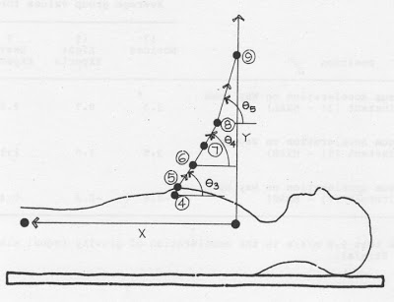

Figure 3. Geometry of the Raising Phase. (4) = CHST, (5) = MXAR, (6) = MXVR, (7) = MNAR, (8) = MNVR, (9) - END. See text for further description of these characteristic instants. Angles are with respect to horizontal, where 3 (circled) is from CHEST to MXVR, 4 (circled) is from MXVR to MNVR, and 5 (circled) is from MNVR to END.

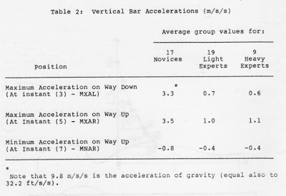

Table 2.

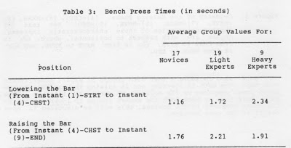

Table 3.

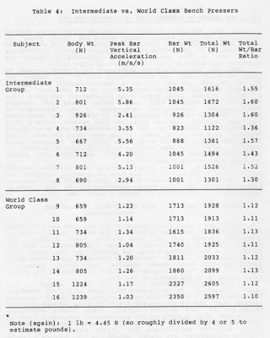

Table 4.

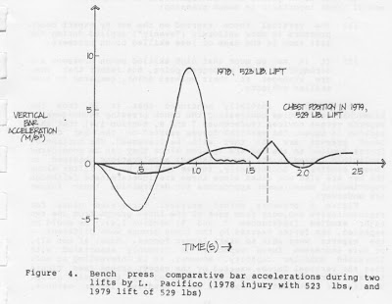

Figure 4. Bench press comparitive bar acceleration during two lifts by L. Pacifico (1978 injury with 523 pounds, and 1979 lift of 529 pounds.

Chapter Two: Biomechanics of the Bench Press, or “Technique is Everything”

2-1 – The Rules of Bench Pressing

No matter whether you are a powerlifter, an Olympic lifter, an athlete in another sport, a bodybuilder or general weight trainer, the rules for correct bench pressing are valuable. Years of experience have gone into their formulation. Some of the rules are actually designed to help prevent injury (for example, the no “bridging” rule helps protect against low back hyperextension injuries, the no “bouncing” rule helps protect against chest impact and shoulder injuries, etc.). What follows are the rules for bench pressing of the International Powerlifting Federation.

Bench Press Rules

1. The lifter must assume the following position on the bench, which must be maintained during the lift: with head and trunk (including buttocks) extended on the bench, lifting shoes flat on the floor.
2. The referee’s signal shall be given when the bar is absolutely motionless on the chest.
3. After the referee’s signal, the bar is pressed vertically to straight-arm’s length and held motionless for the referee’s signal to replace the bar.
4. The width of the bench shall be 30 cm. The height shall be 45 cm. The length shall not be less than 1 meter 22 cm. and shall be flat and level. The height of the bench uprights on nonadjustable benches shall be 87-92 cm. from the floor to the bar rest positions.
5. The spacing of the hands shall not exceed 81 cm., measuring between the forefingers.
6. If the lifter’s costume and bench top are not of a sufficient color contrast to enable the officials to detect a possible raising of the buttocks, the bench top may be covered accordingly.
7. For those lifters whose feet do not touch the floor, the platform may be built up to provide firm footing.
8. A maximum of four and minimum of two spotter-loaders shall be mandatory; however, the lifter may enlist one or more of the spotter-loaders to assist him in removing the bar from the racks. The lift-off may only be given to the lifter at arm’s length and not down at the chest.
9. In the event of a spotter error, a new attempt may be given the lifter.

Causes for Disqualification in the Bench Press

1. During the uplifting, any change of the elected position.
2. Any raising or shifting of the lifter’s head, shoulders, buttocks, or legs from the bench or movement of the feet.
3. Any heaving or bouncing of the bar from the chest.
4. Allowing the bar to sink after the referee’s signal.
5. Any uneven extension of the arms.
6. Stopping of the bar during the press proper.
7. Any touching of the bar by the spotters before the referee’s signal to replace the bar.
8. Failure to wait for the referee’s signal.
9. Touching against the uprights of the bench with the feet.
10. Touching the shoulders against the uprights of the bench.
11. Allowing the bar to touch the uprights of the bench during the lift.

2.2 – Typical Bar Velocity and Acceleration Patterns

The bench press is a quasi-static exercise. The accelerations and velocities are quite small, especially when compared to most human movements. A bar velocity of .4 m/s (which is less than 1 mph!) was discovered to be typical of the bench press (references 7 and 9, section 1.4). Also, bar accelerations for skilled bench pressers are typically less than 1.2 m/s/s (with even gravity at 9.8 m/s/s!). Always interesting to note the interest and excitement each individual derives from a subject which very well may mean nothing to another. And always fun to remember this when considering the ‘importance’ of our chosen interests. The collection of pre-World War Two matchbook covers with misprints that keeps me from losing all hope in living may not mean the same to others. But I highly doubt that! The corresponding rates of muscle extension associated with bench pressing are most probably also small as well. Consequently, due to the small velocities and accelerations involved in the bench press, the force that an individual exerts involved in the bench press, the force that an individual exerts on the bar would seem to be determined primarily by the positions of the bar and the body. (Note: velocity is the “speed” the bar is moving at, and acceleration is how fast that velocity is increasing (if positive) or decreasing (if negative).

Since the horizontal velocities and accelerations of the bar during bench presses are so small that they are essentially negligible, only the vertical velocity and acceleration patterns of the bar will be discussed. Using the techniques described elsewhere (reference 7 and 9, section 1.4) nine “instants” (or common points) in each bench press were selected in order to help in comparison of bench press performances between different skill groups. For example, one such instant chosen was the point during the lowering of the bar where the bar’s vertical velocity was greatest. The nine instants in the sequence in which they occur, as well as the number and name by which they are identified in the figures and tables that follow were:

1. STRT – the start of the lift, when the arms are fully extended and the bar is at rest.
2. MXVL – the instant at which the bar achieves its largest downward velocity.
3. MXAL – the instant at which the bar achieves it s largest upward acceleration while it is being lowered.
4. CHST – the instant at which the bar reaches the chest.
5. MXAR – the first local maximum of the upward acceleration after it leaves the chest.
6. MXVE – the first local maximum of the upward velocity of the bar after it leaves the chest.
7. MNAR – the first local minimum of the vertical acceleration of the bar after it leaves the chest.
8. MNVR – the first local minimum of the upward velocity of the bar after it leaves the chest.
9. END – the end of the lift, when the arms are again fully expended and the bar is at rest.

To get a better feeling for these nine “instants”, as well as to see the typical time histories of the vertical bar velocity and acceleration for a representative subject, please look carefully at Figure 1 and go through the list of instants again.

From a slightly different perspective, Figure 2 shows approximate where the first four instants occur during the lowering phase of the bar during a bench press. Also included in this figure are two angles, taken with respect to the horizontal, which help describe the geometry of the bar path during the lowering phase of the bench press. The first angle, 1 (circled) is the angle made with the horizontal between instant (1) – STRT and instant (2) – MXVL. The second angle, 2 (circled) is similarly taken between instant (2) – MXVL and (4) – CHST. It may help to picture each instant in Figure 2 as the position of the end of the bar as seen from a side view during the lift.

Figure 3 is a similar representation of where the second five instants occur during the raising phase of a bench press. Also included in this figure are three angles, taken with the horizontal as before, which help describe the geometry of the bar path during the raising portion of bench pressing. 3 (circled) is a key angle describing the angle from where the bar leaves the chest ( (4) – CHST) to where the bar reaches its maximum vertical velocity ( (6) – MXVR). 4 (circled) is from this point of maximum vertical velocity to the instant where the bar’s vertical velocity reaches its minimum on the way up ( (8) – MNVR). The final angle, 5 (circled), is similarly from this point of minimum bar velocity to the END – (9) of the lift. Of particular interest later on are 3 circled and 4 circled, so keep these in mind. By the way, you’ll no doubt notice in Figures 2 and 3 that the shoulder is the origin of the coordinate system used here (reference 7 and 9, section 1.4).

It is important to note that although the nature of the bench press (down, pause, and back up again) guarantees the existence of instants (1) to (6) and also (9), instants (7) and (8) need not be distinct from the end of the lift. The existence of distinct minimums of upward bar velocity and acceleration while the bar was being raised was proposed based on my earlier studies of the squat exercise. The proposed existence of these definite low points in upward bar velocity and acceleration during the raising phase in the bench press was verified by the results of the studies on novice and expert bench pressers (references 7 and 9, Section 1.4)

If one combines the results of those two studies, then the typical average values for the bar accelerations at key instants in the bench press are as displayed in Table 2.

Please note in Table 2 how similar the accelerations are for the two expert groups of powerlifters, and how much more peak acceleration the novices have both on the way down and on the way up. Also, note that the novices had a greater negative acceleration (indicating that the bar was slowing in velocity more) on the way up at instant (7). More later on these points.

To finish off this section, it is of interest to note both the total time for lowering the bar to the chest as well as the time it took to raise the bar from the chest to completion. Again, combining the data (from references 7 and 9, section 1.4) the results appear in Table 3.

Note also in Table 3 that both groups of expert powerlifters took more time both in lowering and in raising the bar during the bench press compared to the novices. Of particular interest is how much more time it took both the expert groups to LOWER the bar to the chest compared to the novices. This will be discussed in more detail in the next section.

2.3 – The Degree of Control Used in Lowering the Bar

In this section, I will (hopefully) prove to you that by controlling the bar’s descent better during the bench press (by mainly reducing the bar’s vertical acceleration on the way down to the chest), you can reduce the total force required to bring the bar to rest at the chest and thus dramatically reduce the potential for possible injuries to your shoulder joint.

Back in 1980, in a pilot experiment for a grant proposal to study the bench press, the author (along with Dr. N. Madsen and Dr. McLeod) decided to do a two-dimensional analysis to determine the total vertical force acting on the shoulders during a single maximal bench press using intermediate and world class subjects. Utilizing a high speed LoCam camera and standard two-dimensional biomechanics techniques in our laboratory at Auburn, the peak vertical acceleration of the bar was determined for each subject from the digitized film records. Table 4 lists the results for both groups. The Intermediate group were Auburn athletes with one to two years lifting experience who were filmed in our laboratory, and the World Class group were champion bench pressers whose lifts were analyzed from high-speed films that the author had recorded at the 1974, 1978 and 1979 U.S. Senior National Powerlifting Championships.

In Table 4, it is first obvious that the peak vertical acceleration of the bar on the way down is uniformly greater (by about three to four times) for the less skilled bench pressers during the lift. The total weight supported by the two arms is simply given by application of Newton’s Second Law, i.e.

Total weight = Bar Weight + (Bar Mass + Peak Vertical Bar Acceleration)

Thus, the total force acting on the two arms was calculated for each subject. As shown in Table 4, the actual total loading is uniformly greater for the less skilled bench pressers. For example, Subject 1, although lifting a bar weight of only 235 pounds has a peak loading during the descent on the upper body during the lift of 363 pounds. In contrast, the current World Superheavyweight Bench Press Champion, Subject 16 (Kazmaier), filmed in 1978 before coming to Auburn, only exerted 584 pounds total force (with 528 pounds on the bar).

If one were to construct a ratio of total weight to the bar weight (Table 4) it can be seen that there is a clear trend for the world class lifter to have total weights only ten to thirteen percent over bar weight, versus thirty to sixty percent over bar weight for the less skilled lifters. This simple experiment illustrates that loading on the glenohumeral (shoulder) joint in less skilled lifters is considerably greater than bar weight alone, and the implications for injury (especially posterior shoulder subluxation) are clear. Indeed, it is routinely noted that beginner and intermediate bench pressers, particularly when tired or sloppily trying to “squeeze” out one more repetition bench press, will let the bar accelerate on the way down even more dramatically. While it is not possible to infer particular structural loadings from this simple two-dimensional study, it is probable that such bench pressing can be a causative factor in shoulder and upper body injuries. The obvious point here is to not let the bar accelerate too much on the way down (especially in an uncontrolled fashion) during your bench presses – even during high repetition “light” sets! It is important to realize that doing fast sets of repetitions with lighter weights may in fact be more stressful to your body than doing heavier bar weights with more controlled technique (and lower acceleration). Think about it (the neo-Nazi behind Michael Douglas in Falling Down) . . . most of the top bench pressers do this in a meet! By the way, have you considered that the squat is another example of this concept? Ever try dropping down with a lot of acceleration in a squat? I heartily recommend it to all those I compete against . . . only kidding.

Subsequent studies (references 7 and 9, section 1.4) also verified the results of this pilot study. In general, the group of 17 novices used in these two later studies developed peak downward bar accelerations that were approximately 5-6 times larger than the expert groups (see Table 2). Thus, the best bench pressers seem to have clearly learned to minimize the bar’s acceleration during the bar’s descent. In fact, the later data (to be discussed in section 2.11) indicates that there is a trend for successful lifters to progressively reduce their peak vertical bar acceleration during the descent over the years. For example, multiple world record holder Mike Bridges decreased his peak downward bar acceleration by over four-fold between 1978 and 1980, while his lift jumped significantly. Bridges is a clear example of “smooth” form, since low acceleration type bench presses visually appear as being smooth and effortless. Watching Mike bench, it is clear that he has mastered this aspect of the lift.

When someone does allow acceleration to jump during the descent, he can expect very high loading of his muscular system and his shoulder joint. An example of this was the great bench press and powerlifting world champion Larry Pacifico’s bench press injury in the 1978 Seniors. As shown in Figure 4, a comparison of his 523 at that meet with his 529 at the 1979 Seniors showed that the bar’s vertical acceleration on the way down was about eight times greater than in 1979 when the bar reached his chest in his injury in 1978. The loading on his body in 1978 in this lift was effectively about 950 pounds. Ouch! It is incredible that some lifters with high descent acceleration, likes Lars Hedlund, for example, can stay injury free very long.

The obvious conclusion here is that the novice lifter could reduce the maximum force on his shoulder joints by lowering the bar more slowly. Hopefully, this will lead to a reduced chance of injury, particularly acute injuries. However, the question of whether the novice lifter can make this change in technique remains. Recall from Table 3 that the lowering phase is considerably longer for the competitive lifters. The average times of the lowering phase were 1.16 seconds for the novice group versus 1.72 and 2.34 seconds for competitive groups. The reduction in ability to generate force associated with time changes of this magnitude is certainly small. Each lifter has at his disposal the ability to reduce the maximum joint forces experienced during the lowering phase of the bench press. All we need to do is concentrate on not letting the bar achieve too large a velocity during the lowering phase of the lift . . .

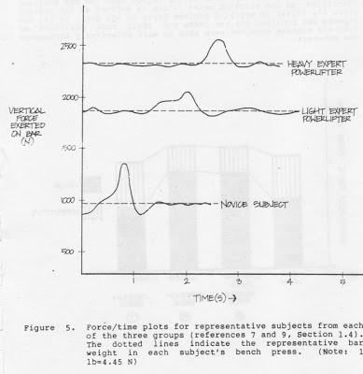

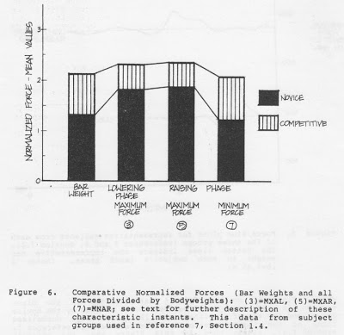

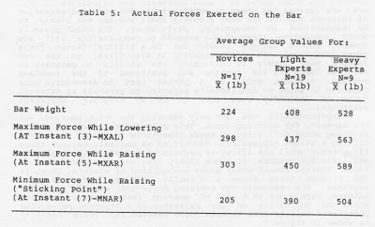

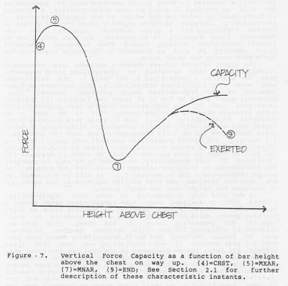

Forces Exerted on the Bar in the Bench Press

Several major points will be emphasized in this section that are of great importance in bench pressing:

(1) The vertical force exerted on the bar by expert bench pressers is more uniformly (“evenly”) applied during the lift than is the case of less skilled bench pressers.
(2) It is not so much that high skilled bench pressers are stronger at their strongest point, but rather that they are stronger at their weakest point, compared to less skilled lifters.

It should be initially mentioned that it is from the biomechanical studies contrasting the bench pressing techniques of experts versus novices (references 7 and 9, section 1.4) that this section is based. The vertical forces exerted on the bar during bench presses are all that will be discussed. The horizontal forces applied to the bar are ignored since they can be considered negligible (based on the low horizontal accelerations obtained in those studies). Additionally, forces applied by the lifter along the bar are also not cited since these are indeterminate (although experimental) measurement approaches for determining these forces are underway.

Figure 5 presents actual vertical force/time plots for representative subjects from each of the three groups from the two major studies (references 7 and 8, section 1.4). As would be expected, the forces exerted by the three groups were different – the experts were able to exert larger forces. Some, if not all, of this increased force capacity is probably associated with increased muscular capacity. However, it is interesting to note that the vertical forces exerted by the expert groups (see figure 5) are more uniform than that exerted by the novice group. Despite the fact that the experts were handling larger weights, their average difference in maximum and minimum force exerted on the bar was significantly smaller, as shown in Figure 5. In other words, the differences in force exerted between the experts and novices were much more pronounced at their positions of minimum force exertion. This can probably be seen even more dramatically in Figure 6 than even in Figure 5. Note in Figure 6 that the top of the black section is the average normalized force exerted by the novice group, and the top of the lined box is the average normalized force of the light expert group (from data used in reference 7, section 1.4). Please note that in this Figure that the greatest differences between these two groups are seen for Bar weight, and more importantly, at the instant of Minimum Force during the raising phase. The reasons that the experts were able to exert more force at their “weakest” (minimum force) point than the novices may be due to a number of factors: (1) perhaps the novices were not able to predict the maximum weight they could lift as accurately as the experts and thus were not required to exert as large a force (relative to their capacity at this instant of minimum force exertion); (2) maybe the experts have benefitted from training effects specific to the region near the bar position identified as the sticking point (which is often defined as the instant where the lifter is applying minimum force to the bar); or (3) the experts had modified the bar paths and their body positions so that the muscles involved were able to work effectively through the movement.

Notice that if you look at the “curves” of normalized Force in Figure 6 (that are made visible by the lines drawn between the mean value blocks), you can see that the experts’ average force pattern is much smoother than the novices. Such a smoother pattern permits a larger weight to be lifted without an increase in the peak force used. If both groups in Figure 6 are exerting maximum force at least until the sticking point (remember this is the point of minimum force exerted on the bar, instant (7)) is passed and the techniques of the groups are equal, then the decreases in force near the sticking point should be similar in nature. But you can see that this is not the case! The difference in maximum and minimum normalized force is only 14% for the competitive group versus 44% for the novice group. The high skilled group was thus capable of exerting 87% more force at the sticking point than the novices!

2.5 – The ‘Sticking’ Point

Any bench presser knows that the “sticking point” is a real (and frustrating) phenomenon, especially in meets. It often seems that there is indeed a sticking point associated with the bench press. The experimental results of all our studies so far verify the existence of a sticking point in the bench press. All subjects exhibit a distinct minimum in vertical acceleration while raising the bar. Newton’s laws indicate that this instant of minimum vertical acceleration is also the instant at which the lifter is exerting minimum force on the bar (instant 7) in Figure 1 and all subsequent Figures). For this reason, the position of the bar at this instant will be referred to as the sticking point. The acceleration histories of all 48 subjects in our studies (references 7 and 9, section 1.4) exhibit the dip associated with the existence of a sticking point. There thus exists a bar and body position for which the lifter is significantly weaker than he is at other positions. This holds true for all bench presses studied.

Let’s look at what’s involved. The effectiveness of our musculoskeletal system in generating an external force depends upon the system configuration. Generation of an external force requires the production of internal moments at various joints. The ability of a muscle to produce a moment at a joint depends upon many factors, including the muscle capacity, the muscle length, the rate of extension of the muscle, the position of the muscle relative to the joint and the recent history (fatigue) of the muscle. (Force Moment; Moment Of Force - A force that produces a twisting or rotary movement in any plane about an axis of motion; it is the rotary effect of an eccentric force. Torque occurs when bones move around each other at joints which serve as the axes of movement. Thus, a muscle force when applied over a range of motion is measured as torque.)

For a given individual the factors most significantly affecting performance in the bench press are geometrical in nature. The bench press is a slow movement, bar velocities of 0.4 m/s (meters per second, 1 m/s = 3.28 feet per second app.) are typical (as shown in section 1.2). The rates of extension of relevant muscles are most probably small and are not unlikely to be significant in determining performance. The bench press is short in duration, times of 3-5 seconds to complete the lift are common. Muscle fatigue should not be a critical factor. For a given individual, his muscle capacity is also fixed, so the two factors most likely to determine the ability to generate an external force are the lengths and positions of the involved muscles. Sticking point is a phrase used to describe a body position in which an individual’s capacity to generate an external force is decidedly less than it is at slightly different positions.

Experimentally one can only identify the force exerted, not the capacity for exerting force. This makes identification of a sticking point difficult. It seems reasonable to assume that while lifting a weight subjectively identified as maximal, maximal force is exerted until the lifter certain of successfully completing the lift. Furthermore, it seems likely that no great increase in force exerted should occur after recognition of success. Thus, if the exerted force shows a dramatic decrease and subsequent increase, the capacity for exerting force must exhibit a similar pattern. Such a dip in a plot of exerted force versus position would be indicative of the existence of a sticking point. The postulated relationship between the force exerted and force capacity is shown in Figure 7.

The point of particular significance in Figure 7 is the point where the force capability is smallest (instant (7)). This is the location of the sticking point. The existence of the sticking point, indeed the variation of force capability with height, is essentially a geometric phenomena. Given a particular level of muscular development, it is the mechanical advantage that can be gained at various positions that determines the force one is capable of generating at those positions. The mechanical advantage is determined by factors such as muscle lengths and lines of action. Those lengths and lines of action are determined by the position of the lifter, in particular by the position of the lifter’s arms.

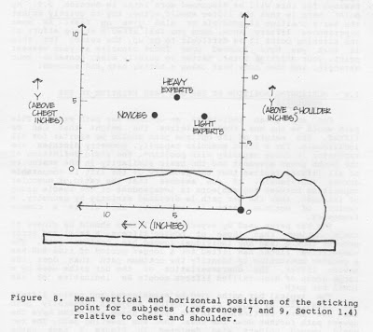

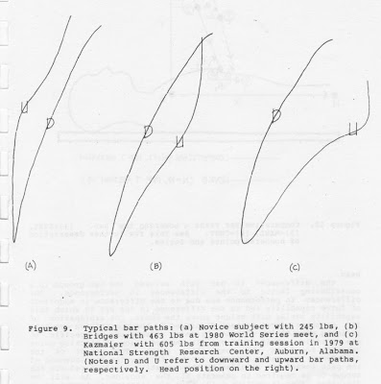

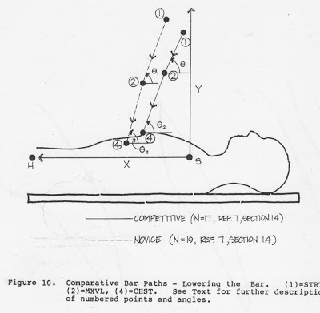

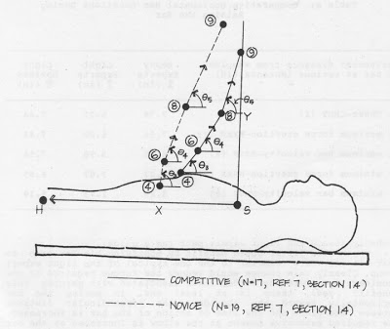

Figure 11. Comparative Bar Paths -- Raising the Bar. (4) = CHST, (6) = MXVR, (8) = MNVR, (9) = END. See text for further description of these characteristic instants and angles.

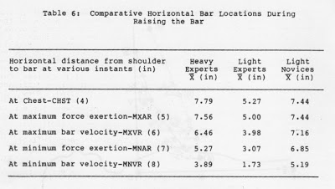

The geometrical nature of the relationship force capacity and position suggests that purely geometrical changes in technique could lead to significant changes in that relationship and hence to significant improvements in bench press performance. The area to be helped most by geometric changes in technique is that portion of the force versus height curve near the sticking point (i.e. in Figure 7, position (7)). An increase in curve height in this sticking point region will directly increase the weight that can be lifted in the bench press.

The degree of the sticking point phenomenon plays an important role in performance of the bench press. The work done on the bar by the lifter during the raising phase must be equal to the increase in gravitational potential energy associated with the bar. Work is an integral of force. To maintain a given capacity for work, a decrease in force in one position must be compensated for with an increase in force at some other position. A decrease in force capacity below the bar weight at one position requires a corresponding increase in force capacity above the bar weight at another position. For a given muscular capacity, the less dependent force capacity is on position, the more weight can be lifted. Bench press training should thus emphasize developing force capacity as much as possible in the entire region of the bar’s path during the bench press.

The highly skilled lifters showed a markedly less pronounced sticking point than exhibited by less-skilled bench pressers. Note, for example, Figures 5 and 6, and Table 5. The differences here were very significant statistically. This increase in force capacity at the high-skilled bench pressers’ weakest (i.e. sticking) point could be due to at least two factors:

1. Training techniques used by the high-skilled lifters that preferentially build strength near the sticking point. This is an area I am presently investigating (i.e., how to train this sticking point region most effectively).
2. Geometrical differences in bench press techniques (to be fully discussed in the next two sections – 2.6 and 2.7).

The second possibility was most intriguing. Could a lifter increase the weight he could bench press by simply changing the path he chose to have the bar follow? In order to evaluate the likelihood of this possibility, we needed to be able to quantify the differences in technique between high-skilled and less-skilled groups (references 7 and 9, section 1.4). As will be discussed in the next two sections, the high skilled subjects DO use technique to increase the weight they can bench press.

It was also very interesting to note that highly skilled lifters that I analyzed over time (unpublished data) showed a considerable increase in their capacity to generate force at their sticking point, while exhibiting a very minor increase in their capacity for generating force off the chest. This data was obtained by analyzing lifters like Bridges, Gaugler, Kazmaier, etc. at Senior National and World Powerlifting meets each year over 2-4 year periods. It was fascinating to note that these lifters’ bar paths (to be discussed in the next two sections) also changed as predicted. In other words, over time these successful lifters changed their sticking point force capacity to some extent by changing their bar path along the lines of our research results (references 7 and 9, section 1.4). A few lifters who did not increase significantly in their bench press performance over the years I monitored (to remain unnamed!) also did not demonstrate the changes in bar path that characterized the others. More work in this exciting field needs to be done.

A final point of interest regarding the sticking point involves where it occurs physically during a bench press. I could easily perform a study of any bench presser using standard cinematographical techniques and biomechanical analysis and pinpoint their own unique sticking point position relative to the chest and the shoulder. Knowing this would permit very useful and exciting training possibilities to increase strength right in this region. Obviously, the analysis also provides equally useful information regarding the lifter’s bar path and how it could be altered to also increase sticking point force capacity (as discussed later). However, since such analysis ma not be possible for everyone yet, I have created an average composite plot of the sticking point positions (means for groups in references 7 and 9, section 1.4) and shown them relative to both the chest and shoulder in Figure 8. This figure should be easy to use in training as a rough guide to position, for example, in a power rack for specific sticking point training. Note, in particular, that the location of the sticking point for the expert groups is closer to the shoulder. Also note that all sticking points are relatively close to the chest (less than 5 inches or so in general).

A final observation on the sticking point, based on my own experiences, is that seldom does a lifter in a meet successfully push the bar through this region once the bar stops here. What typically happens is that the lifter grits his teeth and keeps on pushing here nonetheless. He also uses virtually every body movement possible to him to help in the effort. However, perhaps the only movements possible here are to

1. Move the bar quickly to a preferred path position if possible, or
2. Rotate the upper arms out to the sides.

The typical reaction is to swing the arms out, but this ends up only fatally ending the situation. The reasons for this will be discussed more later in Section 2.9. My point here is that the lifter should either try to QUICKLY adjust the bar’s position if possible or else GIVE UP fast! As most experienced lifters know, once you fail after a strong effort at the sticking point it is difficult to go up. The reason for this is that you have lowered your force capacity at your weakest point, your sticking point. Better to quickly miss, conserve your strength, and then come back using a better path and succeed!

2.6 – Horizontal Position of the Bar Relative to the Shoulders

For any given individual an optimum bar path exists. This path would be the one that maximizes the weight that can be lifted. The nature of the optimum path should be similar for all individuals. For a fixed muscular capacity, geometry dictates the variation in force capacity with position. The rigid definition of the bench press movement and the basic similarity in the anatomies of all lifters implies that the geometry of the lift is comparable across individuals. If one assumes that the ratio of muscular capacities between two subjects is independent of the muscle group of interest, then the bar path is dictated strictly by geometry. A variety of the optimum paths is expected, all within a common framework.

The bar paths used by experienced lifters should be closer to their optimum than those of novice lifters. A trial and error process should lead any individual toward his optimum path. The competitive lifter has lifted for a longer period of time and has a greater motivation to identify the optimum path than does the novice lifter. The characteristics of the bar paths used by a large group of high-skilled lifters should be indicative of the ideal bar path.

The TYPICAL bar paths used by experienced and novice lifters are illustrated by Figure 9. The novice subjects generally push the bar more vertically in the upward phase and often have the upward path further down the chest than in the lowering path. The two world record holders also depicted in Figure 9 have paths representative of experienced subjects in general.

From a quantitative analysis of these bar paths (references 7 and 9, section 1.4), it was shown that the bar path followed by the experienced lifters was significantly different from that used by the novice group. The mean horizontal positions of the bar relative to the shoulder were significantly different between the two groups at every characteristic instant. Mean paths for both groups are displayed in Figures 10 and 11. During the lowering phase the bar paths are nearly parallel with a curvature concave toward the head. The path of the competitive group (see figure 9) is displaced relative to the novice group path approximately 10% of the upper body length from the hip to the shoulder. The competitive group starts the lift 95% of the way from the hip toward the shoulder and touches the chest at 70% of that same length. The differences during the raising phase (see Figure 11) are even more dramatic. The novice group raises the bar initially moving it nearly vertically and then moving it up and toward the head. The competitive group chooses a path with the opposite convexity. The initial movement of the bar includes a substantial horizontal component toward the head. The horizontal differences in the path increase rapidly at the start of the raising phase. At the sticking point this difference is 20% of the upper body length. The paths converge near the end of the lift, the horizontal position differing by 11% of the upper body length in the finishing position. The competitive group finishes with a mean normalized position 1 ± 11% beyond the shoulder toward the head.

The differences in bar path between the two groups is a contributing factor to the differences in performance. The differences in performance are due to the differences in magnitude of force capability and to the difference in the way in which this capability varies with height above the chest. One explanation of the smoother force pattern displayed by the competitive group is training specificity effects. Training effects can be specific to one position. This could explain the reduction of sticking point behavior found in the competitive group. The nature of the difference in paths suggests another factor. The displacement of the path toward the shoulder by the competitive lifter reduces the torque he is required to generate at the shoulder. As will be discussed later in Section 2.10, this minimization of torque is an important result of this horizontal shift of the bar path toward the shoulder.

So far, the bar paths discussed in this section have been those of light experts and novices (from reference 7 of section 1.4). The same trend was also demonstrated for horizontal bar position for heavy expert bench pressers (reference 9, section 1.4). Table 6 shows the horizontal locations of the bar during the raising phase for all three group. Note in this table that the heavy experts maintain a horizontal bar position further away from the shoulder than the light experts. This is probably related to the greater size of the heavy experts and the limitations posed by the fixed grip width (32 inches) on the bar permitted in competition. This may prevent larger, heavier lifts from maintaining geometric similarity with the smaller expert lifters. It may be that the larger high-skilled lifters are replicating the technique of the smaller lifters as much as is permitted within the rules of powerlifting. Note that the heavy experts seek to mimic the path of the lighter experts, and even though the heavy expert group re similar in horizontal bar position to the novices early in the lift, they quickly move the bar horizontally throughout the entire raising phase (see Table 6). The major point is that lifters should develop a horizontal bar path that’s as close to the shoulders as feasible, and work probably toward the light expert path (as a guide).

The novice lifter could benefit by modifying his bar path so that it is more similar to the one typical of the light expert group. Clearly this change would reduce the torque required at the shoulder. Are there any hidden costs associated with gaining this benefit? Yes, there is at least one. In moving the bar horizontally toward the shoulder, the perpendicular distance between the elbow and the line action of the bar is increased. The required extensive moment at the elbow is increased as the bar path is displaced toward the shoulder. The force required from the tricep must be correspondingly increased. For a novice lifter to benefit from a change in bar path he must have sufficient tricep force capacity. The data suggests that the novice lifter could benefit by shifting his bar path toward his shoulder. It appears that the novice is requiring too much moment at the shoulder and not enough at the elbow. A bar path displaced horizontally from the present path that approximately balances the shoulder and elbow moment requirements should exist. This path chance should improve performance without any increase required in muscle capacity. With experience with the new technique, tricep force capacity should increase and allow the novice to choose a bar path that more closely emulates that used by the competitive lifter.

Other interesting questions that remain to be explored here. For example, the significance of the path in determining capacity, and particularly the differences in path during the raising and lowering phases poses some interesting questions about the design and use of exercise machines. Does the use of different paths in lowering and raising the bar “save” muscle force for the raising phase? These interesting questions await further study.

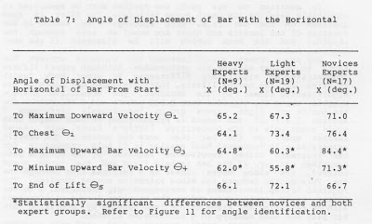

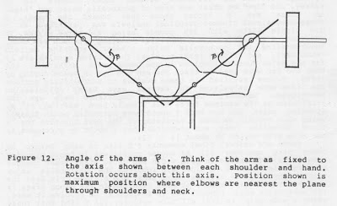

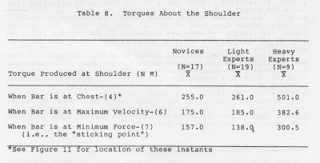

2.7 - The Sequence of Bar Movements Used in Raising the Bar

The differences in bar path used by the expert and novice bench press groups were found to be even more extensive than the horizontal shift of one relative to the other (as discussed in the previous section). The angles used to define the motion of the additional bar from instant to instant during the bench press provided additional insights into the lift. (Please refer to Figures 2 and 3 and especially Figures 10 and 11 of the last section). Note in Figure 11, in particular, the differences between groups for 3 (circled) and 4 (circled). The light expert group (as shown in Figure 11) moved the bar off the chest at an average angle of 60.3 degrees with the horizontal, while the novice subjects average 84.4 degrees for this same angle 3 (circled). This difference in angle was very significant statistically, and raises an interesting question. Does this rapid movement of the bar right off the chest (toward the head) serve to increase the capacity for force exertion when the bar is at the sticking point (by reducing the moment at the shoulder required to generate that force)? Note also in Figure 11 that 4 (circled) results are analogous to 3 circled. Table 7 presents this angular data on heavy expert lifters (from references 7 and 9, Section 1.4).

As shown in Table 7, he heavy expert group has a similar trend regarding the sequence of bar movements to that shown by the light experts. It is important to remember that the significance of the differences for 3 (circled), as well as 4 (circled), between expert and novice groups is magnified when you consider that this marked push toward the head occurs right off the chest (before the bar is but a few inches up!). The important point to remember here is to quickly begin the push of the bar horizontally toward the head right as the bar is first pushed off the chest. To not do so will result in a path not unlike the novice group. I am not saying that one should follow a specific angle off the chest, but rather that every bench presser needs to push MORE toward the head immediately off the chest. It was interesting to note that world class bench pressers I analyzed over time decreases 3 (circled) and 4 (circled) over the years as their lifts increased.

A final point of interest regarding the bench press and competition. It seems possible that a lot of lifters may forget about their technique in competition (or with new personal record attempts in the bench press) and mistakenly push up more than they normally would. From experience, I often find myself thinking more about "blasting" a record bench press weight off my chest than about following a better bar path. When any lifter in this situation sacrifices his technique and "blasts" the bar off the chest his path mimics more the one in Figure 11 for novices, and typically may result in a failed lift. Like in all sports, technique is actually MORE important in maximal, competitive situations. So, try to remember to follow the sort of bar path we've discussed when you're on the platform. It should help.

2.8 - Grip Spacing

In addition to bar path, two factors must be specified to completely describe the bench press technique. The first is hand position on the bar (i.e. grip spacing). The second is the rotation of the forearm and upper arm about an axis through the shoulder and the hand (which will be discussed in the next section, 2.9).

Any bench presser should increase the distance between his hands to further enhance his performance. Although expert lifters demonstrated no significant differences in upper body length relative to the novice lifters, their finishing bar position was significantly closer to the shoulder. The normalized average heights above the shoulder were 0.923 meters and 0.794 meters for the novices and light experts respectively (reference 7, section 1.4). If arm length is proportional to to body length this could occur only if the competitive lifter's hands were placed further apart on the bar than were the novice's. The benefit associated with the increased hand spacing is to help compensate for the increased tricep involvement required by the optimum path described earlier. If the bar is held fixed and the hands moved outward, the elbow moves closer to a vertical line through the bar. This motion reduces the elbow extension movement required. The required tricep involvement is correspondingly decreased. The lifter could conceivably reduce the shoulder torque requirements without affecting the elbow torque requirements by modifying his bar path and hand spacing in a coordinated fashion.

The large expert bench pressers also used grip spacings significantly wider than the novices and analogous to the light experts. For these larger lifters the mechanics of the bench press are affected b the rules of powerlifting. When a very tall individual bench presses competitively, the 32 inch grip width limit works against him since a wider grip would be more advantageous. For very big bench pressers this limit on width roughly approximates a smaller lifter having to "close-grip" his bench presses! Perhaps the rules on grip width can someday be amended to be proportional to shoulder width, height, etc.

As I have just mentioned, yes - I have said here that a wide grip is optimal for bench pressing. My major reasons for supporting this view came from a study that I did with Dr. Nels Madsen back in 1982 (reference 6, Section 1.4). We did a three-dimensional analysis of yours truly performing three types of bench press: (1) wide grip (31 inch), hitting high on chest; (2) wide grip (32 inch), hitting low on chest; and (3) narrow grip (shoulder width - 20 inch), hitting high on chest. (NOTE: the grip spacings here are the distances between index fingers (as in rules), and "low" on chest was base of pectoralis major and "high" on chest was 2 inches above that toward the head). A three-dimensional cinematographical analysis was performed as I did single lifts with 300 pounds using all three styles. In addition, a simplified musculoskeletal modeling approach was used, incorporating the pectoralis major (chest), anterior deltoid (shoulder), and triceps (arm) muscles. These three muscles are by far the major muscles involved in the bench press. Markers on the body and bar were used to track the arm and bar in space during my lifts. Forces required in these muscles to successfully perform the lifts were calculated in several ways using optimization techniques. However, of greatest importance here was the prediction of the maximum force that I could have exerted at my sticking point (or how much I could have maximally bench pressed using each style). We used a variation of the work equation for a fixed direction here, and predicted that I would be strongest in the wide grip styles by about 10 to 23%.

There are several final comments I'd like to make before we leave grip spacing:

1.) As anyone proficient in bench pressing knows, a little change in grip width can cause significant changes in muscle involvement. A wide grip involves the pectoralis major (chest) and the triceps (arm) less, and a close grip does the reverse. The largest muscle by mass involved in the bench press is the chest and it is logical to involve it more, using a wide grip, to lift ultimate weights.

2.) I find that those top bench pressers using narrow grips are few and far between, and more often than not they use a narrow grip because of a former pectoralis injury.

3.) From a mechanical work perspective, the wider the grip the less the distance required to push the bar to completion (and less work required as well). Bench pressers who break world records are typically endowed with (or have well-developed) large chests and short arms. Coupled with a wide grip these people are terrors in competition when when bench press time comes around.

4.) Obviously, a few people can excel in bench pressing with narrower grips, but just think what they could do with a wide grip if they gave it some time. It is important to realize here that narrow grip benchers are tricep and deltoid strong and pectoralis major weak. When switching to a wide grip it is necessary to give yourself some time to get the chest up to par (and for a while your maximum lift will possibly be less with a wide than narrow grip). It just takes some time.

2.9 - Angling of the Arms

The ideal arm position during the bench press is difficult to determine from a two-dimensional analysis. The necessary three-dimensional studies to determine this are presently underway. If the hand is fixed on the bar (which it is) and the bar is not allowed to move, there is still one degree of freedom in positioning of the arms. This freedom is equivalent to a rotation of the arm about an axis (or line) through the hand and shoulder. The range of motion of the rotation during a bench press is small, but critical. The location of the end of the bar and the shoulder cannot be used to determine the position of the elbow. Investigation of the optimal arm orientation during a lift awaits more three dimensional kinematic studies of the bench press.

The angle I have defined is most easily seen (Figure 12) at its maximum position, when the elbows have rotated as far as possible toward the shoulders. From my film studies I have found this to be the final position of nearly every bench presser who MISSES a lift. This also happens to occur at the (guess where) sticking point. What's really funny about this is that any hope of pushing the bar through the sticking point is dashed when the arms rotate to this position. Since the hands can't move outward along the bar, there is little the triceps can do here in extension. Also, the anterior deltoid is largely ineffective by this point, and the pectoralis major is also not at the greatest leverage here either. It would be better to rotate in the other direction (elbows more towards sides) to at least put the arm in a position where the tricep could help more.

This brings up an interesting point, that rotating the arms here is a very crucial timing skill. The narrower your grip also the more critical it is since a narrower grip shortens the pectoralis major and thus makes it less of a contributor to bench press force production (since the shorter a muscle the less force it can generate). Ever notice that the narrow grip bench press specialists have tremendous trouble locking out at the top? With this grip, once they rotate themselves out (as in Figure 12) there is even less help possible from the chest to lock the lift out. I have seen this in Kazmaier and others, and we also showed it in my narrow grip style lift in our three-dimensional study (reference 6, section 1.4). The triceps kill you once you rotate out. Narrow grip benchers and probably ALL bench pressers need to avoid this maximm rotation position until the lift's completion. It will be fun to explore this further and somday show how this rotation should be performed optimally in the bench press.

2.10 - Torques About the Shoulder

A torque (or moment) is a measure of the effect of a force to produce rotation, the "turning effect" of a force, if you will. It is the product of the force multiplied by the perpendicular distance from that force to the point of rotation. An approximation of the total three-dimensional torque required at the shoulder during bench presses was obtained by calculating the moment of the force exerted on the bar about the shoulder (references 7 and 9, section 1.4) All torques calculated i this way are two-dimensional approximations of the net torque actually acting on the shoulders .These torques are due to the total force provided by the lifter (i.e., both arms are included). This is felt to be a good approximation of the total torque about the shoulder, since our three-dimensional data showed this was by far the largest component of the total torque.

Despite the enormous difference in the forces applied to the bar by the light experts versus the novice bench pressers (reference 7, section 1.4), the shoulder torques (whether normalized or not) required by the two bar paths showed no significant differences at any of the characteristic instants (see, for example, Figure 11). In fact, at the sticking point the torque required by the novice lifters was actually less than that required by the light expert lifters was actually less than that required by the novice lifters (see Table 8). Torque requirements were typically of the magnitude of 200 NM for the light experts and novices, as shown in Table 8.

The light experts' path has allowed them to lift 79% more weight without increasing the torque at the shoulder their musculature is required to generate. The large horizontal component of the bar motion as it leaves the chest moves the bar considerably closer to the shoulder when the sticking point is reached. The torque required to prevent the force decrease associated with the sticking point is reduced to a level attainable even in this "worst" configuration. Although the change in bar path may place the muscles crossing the shoulder joint in a position of reduced mechanical advantage, the drastic reduction in torque required would seem to more than compensate. In light of the moment it can produce at a joint or joints, as shown here it is probable that differences in kinematics play a significant role in determining differences in performance between groups.

When heavier expert subjects were later analyzed (reference 9, section 1.4), it was discovered that the torques produced at the shoulder were larger than for the light experts and novices. A look at Table 8 shows that at all positions evaluated they are about twice as large as the the values reported for the two lighter groups. The heavier group did lift 30% more weight and had upper body lengths 9% larger than the light experts (.508 meters versus .466 meters). If geometrically and temporally identical identical bench press techniques were used by all groups, then an increase in torque of 42% would be expected for the heavier lifters. Obviously, a much greater increase occurred. For some unknown reason the larger lifters positioned the bar farther away from their shoulder, relative to their upper body size, than did the smaller lifters. What may explain this unexpectedly great increase is the restriction in grip spacing to a maximum of 32 inches, which may prevent the larger lifters from maintaining geometric similarity with the smaller lifters. With a narrower (relative to their body size) grip the larger lifters are faced with a choice of either increasing moment at the elbow by increasing elbow flexion or of increasing increasing shoulder torque by moving the bar path horizontally away from the shoulder. Apparently, most large lifters choose the second alternative. This leads to the intriguing situation that while the weight lifted does not increase as fast as the body weight, the shoulder torque, which determines the muscle loading, increases faster than body weight. It may be that the heavier lifter is trying to copy the technique of the smaller lifter as much as possible within the grip width limitations of the rules of powerlifting.

Probably the most critical result from the analysis of the heavier lifters is that torques about the shoulder can be expected to be greater for bigger athletes during bench pressing. There is a logical link here supportive of the need for possible additional training of the shoulder and tricep musculature, or greater emphasis on beneficial techniques (horizontal bar path position, etc.) discussed previously. For larger athletes, both of these would appear important to help them handle the larger shoulder torques. Specialized training and technique work is thus probably more important the larger you are.

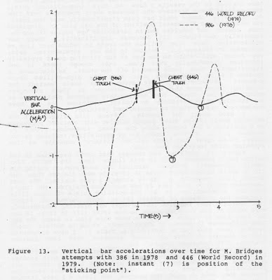

2.11 – Changes Over Time in Top Bench Pressers

I first began taking high-speed films of Senior National and World Championship powerlifting meets ten years ago at the 1974 Senior Nationals (with the generous help of John Pettitt), and over the past decade I’ve been able to collect cinematographic records (using Estar-AH film, which is archival) of many top lifters at different points during their careers. Some lifters, like Mike Bridges, I’ve been able to film every year over five years.

I’ve recorded a number of other top lifters as they have also moved through several weight classes (usually up!) over their careers. Although I am still waiting for the sample of lifters I have over time to increase, there are some interesting trends I have noticed in the results I have to date (unpublished data). High-skilled bench pressers who increase their over time do typically change their bar path significantly over the years. For example, the horizontal position of the bar path is displaced more toward the shoulder and in particular the angles 3 (circled) and 4 (circled) especially (see Figure 11) decrease significantly. Their bar acceleration data also follows the trend to reduce over time as discussed in Section 2.2. Related to the bar acceleration data, the force application to the bar at the sticking point typically increases dramatically over time, even though there is not significantly more force exerted off the chest. As discussed in Section 2.4, it seems that over time the high-skilled bench pressers preferentially get stronger at their weakest (or sticking) point more than they get stronger at their strongest point off the chest. They develop this improved performance at the sticking point certainly by better technique (as we have documented) and possibly by specialized training.

I have seen, for example, lifters like Bridges work the sticking point region using paused singles with overload poundages at a position only a few inches above the chest (remember Figure 8, Section 2.5!). Whether technique or specialized training is the cause, it is clear that these skilled lifters’ capacity at the sticking point increases over time.

Figure 13 typifies the changes that occur over time in the better bench pressers. Note in this figure that the solid line (which represents Bridges’ vertical bar acceleration during his 446 lb. world record bench press in 1979) is much flatter than the dotted line denoting a 386 lb. attempt a year earlier. The most important thing to note here is how much more positive the bar’s vertical acceleration is at the sticking points of these lifts (compare the positions of instant (7) in both curves of Figure 13). Newton’s laws indicate the Bridges’ was exerting considerably more force at his sticking point in his later lift in 1979. It can be seen also in Figure 13 that he took much more time to lower the bar (see difference in points of chest touch), which is another trend evident over time (as in Section 2.2, Table 3). I have documented similar changes in other top bench pressers over time besides Bridges, like Kazmaier, Gaugler, etc.

The real value of analyzing lifters’ performance over time is to document what changes in technique are associated with greater poundages lifted. Conversely, it can also work to help those not progressing in bench press poundage to identify what technique changes they need to make. For example, the lifters I have tracked over time who have not progressed significantly also did not have the technique changes typical of the successful lifters. One superheavyweight, the great P. Wrenn, had nearly the same technique each of the years I analyzed his performance using the same poundage of 524 pounds. Perhaps if he had made the technique changes we’ve discussed he could have pushed his lift up even beyond this respectable poundage.

It would certainly be valuable to analyze our top powerlifters every year, six months, etc. in order to help identify their technique development and suggest any needed changes. Perhaps between the Senior Nationals and the World Championships our U.S. team could be analyzed in this manner. The United States Olympic Committee funds this type of biomechanical analysis for most Olympic teams at their meets throughout the year. For example, the men and women track sprinters were analyzed at many top meets over the past three years prior to the Olympics, and biomechanical changes in their technique calculated and pointed out to their coaches. There’s no reason in the world why we can’t do the same for our lifters (at all levels). This is a good way to objectively diagnose the effects of different training programs over time. In any case, I will continue to collect films whenever possible in order to keep developing our database on bench press techniques.

2.12 – The “Pause” in Competition

In powerlifting competition, the lifter must “pause” at the chest during the bench press before pushing the bar up to completion (see Section 2.1). At this position the bar must be momentarily motionless as the lifter waits for a signal from the referee signaling that he may begin pushing the bar. Like any powerlifter, I have experienced quick pauses in competition as well as some that seem an eternity (you’re just sure the referee has gotten up and gone on a break!). On the average, the “pause” lasts about two seconds.

Although the major reasons for the pause in the competitive bench press are undoubtedly to insure consistent and fair judging of the lift and even to reduce potential injury from excessive bounces . . . it sure doesn’t help bench press poundages! As most powerlifters are well aware, a paused bench press is a lot harder to do than a “touch-and-go” or slightly bounded lift. Personally, it occurs to me that we could make the pause less devastating on bench press poundages, more consistent than possibly even the best judges, and make it more like the touch-and-go lift we all enjoy more . . . if technological changes are made in the pause signal procedures. I hope to present these at some point to the governing bodies of powerlifting.

But, why does the “pause” hurt bench press capacity? First of all, let’s examine the concept of “elastic energy”. Let’s look first at a scene where we have a powerlifter on a pogo stick bouncing along the road. Each time he lands on the road, energy is stored in the pogo stick’s spring and this energy is subsequently released during the elastic recoil as he takes off again. This suggests that in a similar manner energy might be saved if springs were somehow built into the human body. These springs which store the energy and release it again when required would allow our powerlifter to bounce along using much less power and this time without the pogo stick. Kangaroos, for example, are so good at this that they require less energy the faster they hop!

There is, in fact, evidence that a good deal of energy in human motion is saved by elastic structures in the body (used much like the spring in a pogo stick). One such study (reference 1) showed convincingly that energy is stored by elastic structures in human legs. The oxygen consumption of men was measured while they performed squats 20 times per minute. In some of these experiments the subjects “bounced” at the bottom of the squat and in others they stopped at the bottom for one second to avoid any rebound effect. On the average, the subjects used 21 to 27% less oxygen when using the slight rebound at the bottom of the squat! Apparently, the rebound saved a good bit of energy. Indeed, other studies verify this finding and show that a rebound at the bottom of a squat or vertical jump can increase the upward force applied by as much as 20 to 30% (reference 2, reference 3).

The mechanisms by which this phenomenon occurs has been studied more recently (reference 4, reference 5). It has been found that if a muscle is stressed (during an eccentric contraction – as when going down in a bench press), almost immediately before the muscle shortens (during the concentric contraction – when coming up in the bench press), then there will be more energy available to the upward motion. This means that there will be more weight lifted in the bench press. In other words, one needs a count movement followed almost immediately by the movement desired. Note that in terms of timing the eccentric phase must be followed very quickly by the concentric phase. Hence, a rebound at the bottom of the bench press is very helpful in getting more weight lifted.

It has also been found that the velocity of stretch of an active muscle (during, for example, the rebound or “bounce” at the bottom of the bench press) determines how much storage and utilization of this elastic energy actually takes place (reference 2, reference 3). There is an optimal amount of speed in this rebound (or “bounce”) at the bottom of the bench press that each powerlifter should use. Obviously, many factors (like bar momentum, the physical condition of the lifters, etc.) determine how much of a rebound load each individual powerlifter can beneficially tolerate in bench presses. This could possibly be determined for each lifter through biomechanics research.

In the research that I have done on the squat, I found that bar momentum must be controlled on the way down during the squat until perhaps a few inches or so above parallel. Typically after this point is reached, the top lifters then begin to increase the velocity of the descent before starting to drive up out of the bottom. Less skilled squatters were found to let bar momentum get out of control early in the squat and typically reach the bottom with higher rebound velocities (or “bounce” than the better squatters. It seems logical that less skilled or beginning lifters are less able to tolerate these greater rebounds than top lifters can! This is mainly because training has been found to help increase the ability to store and retrieve elastic energy. It has also been shown that males can usually handle greater rebound loads than females (reference 5).

Where is all this elastic energy stored? Since we don’t actually have springs embedded in our bodies (although one can’t always tell what the Soviets, the East Germans, etc. will do next), the energy must be stored somewhere in the body before being used later. This energy is stored in the body primarily in the tendons and to a lesser extent in the elastic components of the muscles themselves.

Now, my discussion so far has been about how elastic energy is stored briefly in the body by a counter movement before being retrieved to help the movement start. I have discussed the squat in particular, although this also explains why bench press repetitions are easier with either a bounce or touch-and-go than when paused. We lose virtually all the elastic energy during the second(s?) we are holding the bench press pause while waiting for the referee’s signal. From what we’ve seen so far, it does make sense for a lifter to try to “anticipate” the referee’s signal and try to minimize the time of his pause as much as possible. Biomechanically, letting the bar sink in briefly after a pause before pushing the bar up (or “heave” as it’s often called) doesn’t make much sense either, since:

1.) letting the bar sink into the chest increases mechanically the work necessary in the lift; and
2.) there is probably not much chance to “restore” significant levels of elastic energy to be of much help off the chest.
Rather, it seems better to keep the bar from sinking in and try to “anticipate” the end of the pause. It’s hard to tell whether as much elastic energy is stored during a bench press as in a squat, but I doubt it. Nevertheless, keeping the pause as short as possible will decidedly help the bench presser’s performance. Regarding training for the pause, it seems much safer to NOT use pauses extensively in bench press training. If done, the ability to store elastic energy will not be trained, and consequently it may end up that on a “shorter” pause in competition someday you’ll miss out on what could have possibly been a successful lift if “touch and go” style bench pressing was mainly done in training. It has been my personal experience that pause bench presses leave me “flat” (or feeling as if I’m without possible elastic energy storage ability!). However, I DO think techniquewise that “touch and go” pauses are smart to do prior to a bench press competition. I do not believe that excessively long pauses are valuable, whether it’s after a few seconds or an hour on the chest, the elastic energy transfer is lost anyway.

References

(1) Thys, Hl, Saraggina, T. and Margaria, R., Journal of Applied Physiology, 32, 491-494, 1972.
(2) Cavagna, G.A., Dusman, D. and Margaria, R., “Positive work done by previously stretched muscles”, Journal of Applied Physiology, 24, 21-32, 1968.
(3) Komi, T.D. “Neuromuscular performance: Factors influencing force and speed production”, Scandanavian Journal of Sports Science, 1, 2-15, 1979.
(4) Asmussen, E., and Bonde-Petersen, F., “Storage of elastic energy in skeletal muscle in man”, ACTA Physiologica Scandanavia, 91, 385-392, 1974.
(5) Komi, T.D., and Bosco, D., “Utilization of stored elastic energy in leg extensor muscles by men and women”, Medicine and Science in Sports, 10, 261-265, 1978.

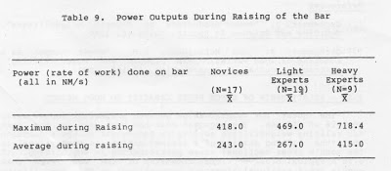

2.14 – Hand/Finger Orientation in Holding the Bar

There are three major methods in vogue for grasping the bar during bench presses: (1) “Normal” grip with palms facing away from head and fingers wrapped around the bar; (2) “Balance” or “False” grip with palms facing away from head but fingers not wrapped around the bar and usually only touching the bar (normally on top) for balance; and (3) “Reverse” grip, popularized by the two bodybuilding brothers “The Barbarians” and Anthony Clark, where the bar is gripped with the palms facing the head.

The most dangerous, of course, is the balance grip where the fingers do not wrap around the bar. I have seen a number of lifters use this, but seldom the best bench pressers. I believe the reason that most top bench pressers prefer the normal grip is that when you use the bar path we’ve discussed, the fingers wrapped around the bar may help both in producing and accommodating the horizontal motion of the bar. I have seen too many bars dropped (even in national competition) using the balance grip, and I caution against its dangers. The reverse grip, believe it or not, although awkward and feeling for most, should not significantly hurt bench press performance. The reason for this is that triceps force capacity does not depend on what grip is used (i.e., forearm pronation/supination).

No matter what grip is used, it is most important to realize that besides controlling the bar and ensuring that it doesn’t fall out of the hands, the grip primarily serves to transfer force from the body to the bar. Since these forces are primarily transferred through the ulna bone of the forearm to the bar, it seems valuable to position the bar near the ulnar surface of the hand (on the little finger side of the palm). An extra benefit obtained from placing the bar across the ulnar surface of the hand has to do with one of the body’s “protective” neuromuscular reflexes.

The human body has a number of these protective neuromuscular reflexes that serve mainly to protect the body from injury. It has been shown, for example, that pressure on the ulnar side of the hand (near the fleshy part of the palm on the little finger side) causes extensor or stabilization response in the upper arm. This reflexively aids the stability of the whole upper arm by stimulating greater contraction of the elbow extensors, especially the triceps.

As you may have noticed, a number of top lifters can be seen pronating their forearms to be sure that the bar rests not transversely across the center of the palm, but rather more on the ulnar surface of the hand. I have often taught this extensor reflex maneuver to beginning weight training classes by instructing them to put the weight on the ulnar surface of the hand during all sorts of triceps exercises (triceps pushdown, dips, etc.). You will be surprised if you try this at how powerful and comfortable this maneuver makes the arm feel.

An additional benefit of having the bar positioned over the ulnar surface of the palm (besides those just discussed) is reduction of the wrist torque. Those who place the bar far up on the palm can dramatically increase the torque about the wrist joint. For all bench pressers, using tight elastic wrist wraps (permitted by the rules of Powerlifting) can help relieve these wrist torques. Although I feel it’s best not to use these wrist wraps all the time in training (so that the wrist connective tissue develops fully) it doesn’t seem to hurt, especially in competition. I recommend them in all competitive or maximal training efforts.

2.15 – Symmetrical Loading of the Bar

The way in which the barbell plates are placed on the bar, as well as the spacing of the hands on the bar are important in bench pressing. The narrower the grip the more important the symmetrical placement of the plates on the bar. With heavy weights in particular, I strongly recommend that the bench presser: (1) check that the plates are positioned so that the heaviest plates are closest in; (2) use the heaviest plates when possible, and I even mean 100 lb. plates as soon as the poundage permits. Even though a lot of plates “look” more impressive, it is better to go to the larger (more centrally located) plates; and (3) always use collars to keep the plates from inadvertently sliding further out toward the ends of the bar. The logic behind all three of these suggestions is that the lateral torque about each shoulder should be minimized as much as possible in order to avoid asymmetry and potential injury. Every bench presser should PERSONALLY check these.

It is similarly important to evenly grip the bar (again, especially with narrow grip spacings). The knurling can be used as a guide to ensure symmetric hand spacing. Bench presses should preferably be handed off and spotted by a single spotter who grabs the bar in the middle. I prefer this (even though two spotters, one on each end of the bar, would seem desirable.) since it is typically difficult for two spotters to coordinate their action without asymmetry and potential injuries. Obviously, this all becomes more important the heavier the weight in the bench press. Finally, if you are significantly weaker in one arm I don’t recommend using an offset grip spacing (with the weak hand closer in) except for emergency situations like a meet. It is more preferable to use symmetrical lifting and let the weight ease back up than to risk injury by overloading the “stronger” side.

2.16 – What if You Miss?

Statistically, weight training is one of the safest activities you could possibly engage in. However, there have been occasional severe injuries and even a few deaths attributed to weight training. Most of these deaths (however few they may be) occurred when performing (guess what) bench presses. Typically this has occurred when people were bench pressing alone without a rack or catchers, got pinned under too heavy a weight and couldn’t get help. Not a very pleasant scenario, but one has to ask – what were they thinking!

When you miss a lift while bench pressing alone, unless you use a rack or boxes, you are suddenly in an extremely dangerous situation. Don’t be a fool. Devise a safe way to bench safely on your own. Enough said about something so obvious.

2.17 – Power Output

Power is defined as the rate of doing work. Conceptually, it can be thought of as the ability to do work (or exert force over some distance) quickly. The maximum and average mean values during raising the bar are shown in Table 9 for all the groups studied 9in references 7 and 9, Section 1.4). It is first apparent that the power outputs of the two light groups were not significantly different. However, the power produced by the heavier lifters was over 40% greater than the lighter groups. This was true (see Table 9) for both the maximum power (i.e., the instantaneous maximum product of force on the bar and bar velocity) and also for the average power during the raising phase (i.e., the ratio of work done on he bar to the time required to lift it). It should be mentioned that the higher power outputs recorded for the heavier lifters was larger than the increase expected from the heavier weight lifted alone. However, this is reasonable since Olympic lifting results (see reference 1) support the trend for greater power outputs for lifters of increased bodyweight for any given movement. Since these heavy powerlifters (again, from reference 9, Section 1.4) have more body mass one would expect that their greater muscle size would permit greater strength and power production. This is reflected in the fact that even though the heavy elite powerlifters lifted about 30% more weight than the light experts, they pushed the bar up .3 seconds faster (see Table 3).

These power outputs (from Table 9) are small relative to values reported in the research literature (reference 1). Values of up to 6000 NM/s have been measured for Olympic lifters (reference 1). Additionally, in 1980 I did a study with Dr. John Garhammer where we compared the power output in the Olympic versus Powerlifts. Generally the power produced in the Powerlifts was at least one-half as much as in the Olympic lifts (reference 2). Two implications arise from this information: (1) Powerlifting is perhaps not the best name for our sport, since our power outputs are actually on the low end of powers produced in human activities. Perhaps we should rename ourselves more appropriately “strength lifters”, etc.; and (2) The use of training programs especially designed for peaking power production (as typically used for Olympic lifters) may need rethinking. The degree to which the development of either strength or power should be emphasized in bench press training programs is a very interesting albeit difficult question. Personally, I feel that most bench press training should emphasize strength development over power.

References

(1) Garhammer, J. “Power production by Olympic weightlifters”, Medicine and Science in Sports, 12:54-60, 1980.

(2) Garhammer, J. and McLaughlin, T.M. “Power output as a function of load variation in Olympic and Powerlifting”, Abstracts: Journal of Biomechanics, 13:198, 1980.

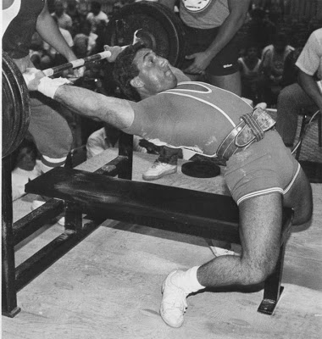

Chris Confessore

2.18 – Relationship of Bench Press Capacity to Weight

The quest for relationships between bodyweight and muscular work is an old one. The argument that has been used is the past for relating weightlifting ability to bodyweight is the assumption that the lifting ability of a trained athlete is proportional to the muscle cross-sectional areas participating in the lifting. If ‘d’ is a typical cross-sectional dimension of the body such that muscle cross-sectional areas are proportional to d*d, then lifting ability is proportional to d*d, or :

Lift ~d*d

Since one’s bodyweight is proportional to volume (or d*d*d) then the lift is proportional to the bodyweight in the power law relation of the form:

Lift~(bodyweight)²

Where a/~ is the exponent of the power law relation and equals (2/3). Therefore, by this line of thinking a person’s lift should be proportional to their bodyweight raised to the 2/3 power, or:

Lift~W⅔

If this is true then man’s lifting capacity in weightlifting competitions should show this relationship. In 1956, Lietzke (reference 1) found that a plot of the 1956 world record totals in the classic found that a plot of the 1956 world record totals in the classic Olympic lifts (3 lifts) versus bodyweight was indeed linear on a log-log plot with a slope of approximately (2/3), hence confirming this power law relationship.

Lietzke suggested that in the future weightlifting totals would probably increase, but the slope of the line drawn through the points of weightlifting totals versus bodyweight (plotted on log-log paper) should continue to be approximately (2/3). It was Lietzke’s results that motivated me to investigate the applicability of power relations to different lifts, especially powerlifts like the bench press, to see if these arguments were applicable to such different lifts.

Analysis (reference 2) of the relationship of (3 lift) Olympic lift totals from 1952 to 1972 (using Olympic records) found that this relationship did still hold, with the exponents in the power law still equal to (2/3). Probably this increased relationship between bodyweight and lifting capacity for the current (2 lift) Olympic lifts has to do with the greater proportion of muscle mass participating in the two remaining lifts. The stats show an even greater relationship exists between bodyweight and powerlifting ability (reference 2).

A look individually at the three powerlifts (and totals) was next undertaken. It was quite interesting that in order of ranking, THE BENCH PRESS WAS MOST RELATED TO BODYWEIGHT, followed closely be the squat and then the deadlift (which was only related by an exponent (a) of about .86). What this helps explain is why many of us who bench press have noticed a loss in benching strength with even small decreases in our bodyweight. A loss of bodyweight thus typically will affect bench pressing poundages more than, let’s say, it will limit your ability to do the same deadlift maximum. Or conversely, this also explains why a gain in bodyweight typically seems to help increase your bench press (as well as squat) more than it affects deadlift poundages. This knowledge can be helpful to powerlifters or athletes who lose or gain great amounts of bodyweight quickly, in terms of rough selection of the proper weights use in the three powerlifts after experiencing the bodyweight change.

Further work on the relationship between the bench press and other powerlifts could lead not only to being able to predict future records, but also possible in generating a more valid and equitable method for determining the best lifter pound-for-pound in Olympic lifting or Powerlifting than current methods (Hoffman, Schwartz, Malone, etc. Formulas). In any case, if your bench press goes down, you at least now have another excuse (and you can claim it’s due to a loss in bodyweight)!

References

(1) Lietzke, M.H. “Relation between weightlifting totals and bodyweight”, Science, 124:486, 1956.
(2) McLaughlin, T.M. and Lardner, T.J. “The theoretical relationship between bodyweight and man’s lifting capacity”, research paper in preparation, 1984.

2.19 – The Importance of Chest Size

If you look at the physiques of most champion bench pressers, they typically have either a huge chest, short arms, or usually both. With a fixed arm length and grip spacing, the higher your chest is above the bench the less mechanical work you have to do. Work as defined here is the product of the force acting on the bar and the displacement of the bar in the direction of the applied force, which roughly is vertically upward in bench pressing. If you put some towels or rubber pads on top of your chest during bench pressing you will see that with the same grip spacing on the bar you can probably lift more weight. Consequently, developing the size of your chest is important to bench press performance and a reason why the bench press was shown to be so highly related to bodyweight (in the last Section, 2.18). It appears helpful to develop and maintain chest muscle mass to get and keep a big bench press. In fact, if you lose a lot of bodyweight and, let’s say, the height of your chest is reduced by even 1/4 of an inch – then the mechanical work you have to do will increase.

What’s interesting also is that letting your chest size diminish causes the bar to go down lower than normal (an extreme case would be to even allow sinking of the bar into your chest). When this occurs the key muscles involved in the bench press at the bottom (in particular the pectoralis major and triceps see 3.1) must work at muscle lengths they are not typically accustomed to. Consequently, the maximum force you can generate may be reduced.
Years ago, the great world champion bench presser and powerlifter, Larry Pacifico, visited the National Strength Research Center and in a workout showed me his version of getting the body optimally positioned for the bench press. Basically, the idea involves positioning the body to get the chest as high above the bench as possible. This is exactly what you need to do to reduce mechanical work and hopefully push up more weight in your bench press. It also makes sense, from a work perspective, to avoid letting the bar sink into your chest. Finally, as I mentioned in Section 2.8, a wide grip will also help reduce the mechanical work you have to do.

When I’ve taught weight training classes to novices I’ve always noted that the long-armed and small-chested “basketball” physique types had problems in bench pressing much weight compared to more amenable body types (larger chests, shorter arms lengths). Although obvious, keep this in mind. If I were of the long-armed and small-chested body type I would:
(1) work hard to increase muscle mass of my chest;
(2) use the widest permissible grip spacing;
(3) position myself to get the chest as high as possible off the bench; and
(4) not permit the bar to sink in at chest impact.

In fact, all of us need to follow these suggestions to help optimize our bench press.

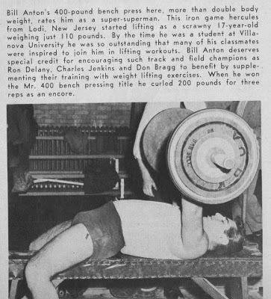

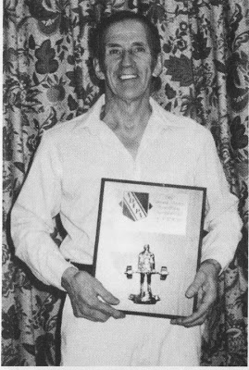

Ed Jubinville

Chapter Three: Developing the Key Muscles Involved in Bench Pressing

3.1 – What We Know About Muscle Involvement in the Bench Press

How do we know what muscles are involved in the bench press, when they’re involved, and how much? Very good question! The prediction of individual muscle force involvement during human sport and exercise motions is no trivial research effort. Three-dimensional musculoskeletal modeling techniques incorporating input from three-dimensional cinematography, electromyography and force transducers on the bar are needed to someday answer this question fully. An example of the complexity of such studies can be seen in reference (1). What’s also important in such analyses is that there are a larger number of unknown muscle forces to solve for than there are equations to work with. Thus, a knowledge of how the body (i.e., the nervous system) calls muscles into play during a bench press is also needed. Needless to say, it’s not a trivial research problem, but along with my colleagues I have been steadily working toward its solution with the “pilot” two and three-dimensional studies discussed in Section 1.4 and throughout this book. Eventually (especially if funding is available) these questions will be answered.

Until then, let’s look at what we know about muscle involvement in the bench press as determined by a number or our pilot studies. Keep in mind throughout the ensuing discussion that these comments must be considered “best” guesses until more sophisticated studies are undertaken. Three pilot studies will be discussed that relate to muscle involvement in bench pressing.

The first study was conducted in 1979 with the kind assistance of W. Kazmaier, World Superheavyweight bench press champion as subject. As depicted in Figure 14, simultaneous film and electromyographic (electromyography, or “EMG”, involves monitoring electrical muscle activity) data was collected as Kazmaier performed a great variety of bench press styles (varying mainly his grip width and where the bar touched his chest). Weights were incremented as he went through each style of bench press for a given poundage. Some of the major conclusions of this analysis were:

(1) The effects of even small (1-2 inch) changes in grip spacing were significant in terms of muscle involvement. Most bench pressers can “feel” this dramatic change in muscle load sharing as they only minimally widen or narrow their grip during bench pressing;
(2) Pectoralis major (sternal portion) was more involved with wider grips and less involved with narrower grips;
(3) Triceps activity was conversely more involved with narrow grips and less involved with wide. Also, at the start of the push off the chest, the greatest burst of triceps activity. The other major area of activity was in the upper portion of the lift, after the chest’s major activity (which was generally from the chest until half to two-thirds of the way up); and
(4) The anterior deltoid was greatly involved in all styles of lift and at virtually all portions of each bench press.

The second study of interest was an investigation of both the bench press and incline presses sponsored by Diversified Products Corporation in 1980 (reference 8, Section 1.4). Similar cinematography with synchronized electromyography of the triceps, anterior deltoid, and both parts of the pectoralis major (sternal and clavicular). The sternal group of fibers are those originating from the sternum (which are most of the fibers in the chest) and the clavicular group originate off the clavicle. Only one subject was used, who was a skilled collegiate powerlifter with five years training history. To summarize the results for the bench press for this subject:
(1) Two grip widths were used, both a wide grip (32 inch) and a narrow grip (18 inch);
(2) When the bar was lowered to the chest all muscles showed considerable activity regardless of grip width. During the lowering, the wide grip involved the triceps less and anterior deltoid more than was the case during the descent with the narrow grip;
(3) As the bar was initially pushed up, peak activity for all muscles was noted shortly after the bar began its upward movement from the chest;
(4) More anterior deltoid activity throughout the entire lift was noted when the wide grip was used;
(5) Triceps activity was less continuous with the wide grip and concentrated most near lockout and barbell support;
(6) When a maximal bench press effort was made the greatest increase in peak activity occurred for the triceps! The smallest increase in peak activity occurred for the anterior deltoid.

As for the second study’s results for incline bench pressers:
(1) Two incline settings were used, and both the wide and narrow grip spacings were again used at each incline;
(2) When going from flat bench presses to the low incline and then to the high incline (no matter what grip was used), pectoralis major (sternal) activity decreased proportionately. This is probably why people who do inclines are often seen arching their backs in an attempt to “flatten” out their chest and get more sternal pectoralis fibers involved. Better to do flat benches!
(3) At either incline the narrow grip involved more activity of the smaller group of clavicular fibers of the pectoralis major than did the wide grip;
(4) Narrow grip inclines provided more triceps activity than the wide grip at either incline;
(5) Peak activity of all muscles occurred at about halfway up at both levels of incline;
(6) At the finish of some repetitions a large burst of anterior deltoid activity was sometimes seen in an attempt to stop the forward drift of the bar between repetitions.

In 1981 a third study was undertaken (reference 6, Section 1.4) using a more sophisticated analysis. Three-dimensional cinematography and musculoskeletal modeling techniques were used to predict involvement of the triceps, pectoralis major (sternal portion only) and anterior deltoid during the three types of bench presses with yours truly as subject (this was discussed more in Section 1.4 and especially 2.8) The results indicated that as far as muscle activity was concerned:
(1) Triceps involvement is so large near the end (or top) of a bench press (especially with a narrow grip), that it is the limiting factor in the lift in this region;
(2) During the rest of the bench press (from just off the chest until perhaps halfway to two-thirds of the way up) the pectoralis major is the limiting factor and most involved;
(3) The anterior deltoid in both grips is near maximally involved during the entire lift, using any style;
(4) A wide grip keeps the pectoralis major at a greater muscle length longer during the lift and permits the muscle to be of more help to successful completion; and
(5) A narrow grip involves the triceps more and the pectoralis major less.

In summary, it should be obvious that the results from these three studies are remarkably consistent even though different research protocols, subjects, etc. were used. I strongly suggest that the information just discussed be studied carefully by the serious bench presser. There is a lot of useful information here with direct implications for training this lift. Even though more advanced studies still need to be done, the results of these three separate studies correlate extremely well and serve as a great starting point for the sections to follow. With these results in mind, let’s now look at how we might train the key muscles involved in bench pressing.

References
(1) McLaughlin T.M. and Miller, N.R. “Techniques for the evaluation of loads on the forearm prior to impact in tennis strokes”, Journal of Mechanical Design, Vol. 102: 701-710, 1980.

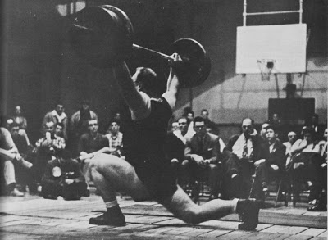

Norbert Schemansky

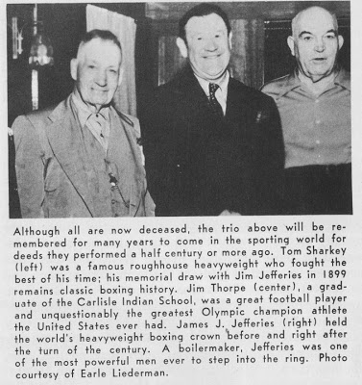

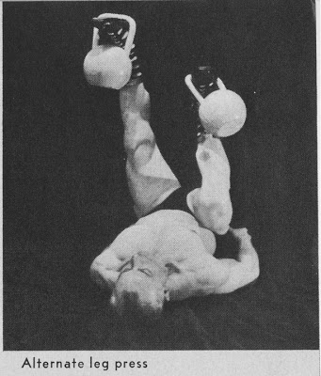

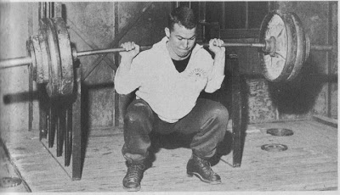

3.2 – Training the Chest

The key muscle of the chest is the pectoralis major, which for reference can easily be palpated and is superficial enough to be clearly seen on most people (or refer to any anatomy text). This muscle has two muscle fiber groups:

(1) the Clavicular portion – whose fibers originate from the clavicle and insert via the common tendon in the humerus (upper arm bone), and
(2) the Sternal portion – whose fibers originate off the sternum and also insert via the common tendon on the humerus.

It is important to note (relative to the bench press) that by far the most important group of fibers in the pectoralis major is probably the sternal portion. I say this because the sternal group of fibers constitutes the largest group of fibers in the pectoralis major muscle and also is a portion of the muscle that horizontally adducts the arm (which is involved in the upward phase of the bench press and fly motions). On the other hand, the clavicular portion of the pectoralis major acts primarily much like the anterior deltoid to cause shoulder flexion (which looks like the upward phase of a front lateral raise).

To summarize the results of our studies done so far that have tried to estimate muscular involvement of the pectoralis major during bench presses (see Section 3.1):

(1) There is generally more pectoralis major involvement when wider grip spacings are used during the bench press;
(2) The greatest involvement of the pectoralis major during bench presses occurs from the bar’s position on the chest to about one-half to two-thirds of the way up in the lift; and
(3) When one goes from flat bench presses to incline bench presses, as the incline angle increases there is correspondingly less involvement of the sternal fiber portion of the pectoralis muscle and more of the clavicular fiber group.

The implications of these results to training the pectoralis major muscle for the bench press are significant. In order to involve the important sternal group of the pectoralis major muscle, one should primarily work the chest using wide grip bench press (or dumbell bench press) motions. Other similar movements involving the same horizontal adduction motion (like heavy dumbell chest fly motions, etc.) can also be done. However, keep in mind that such movements are probably not much different than wide grip barbell or dumbell bench presses. I personally recommend that the upper arms be kept out perpendicular to the torso (as at the end of a bench press) when doing wide grip chest work, in order to reduce triceps involvement and consequently involve the pectoralis major more. Personally, I prefer heavy dumbell bench presses with the wide grip style whenever possible (and when spotters are available to help here), mainly because dumbell training requires more involvement of the shoulder girdle muscles to coordinate dumbell position in space.

As many top bench pressers I’ve trained with have done over the years (like Kazmaier, etc.) our research showed there is a logical basis for doing your wide grip chest development work through the range of motion bounded by the chest to perhaps two-thirds of the way up. However, these “non-lockout” style bench presses will not involve the triceps near their important top position involvement, so it is important to train the triceps separately if this style chest training is done exclusively. It is hard to say how much different this may be than complete wide-grip movements, but it would appear prudent to use both this non-lockout style as well as complete movements in a chest development program.

To best involve the large sternal fiber group of the pectoralis major muscle, one should primarily work the bench press from flat to low incline angles. From our results, I would limit this to low incline angles not exceeding perhaps 30 degrees relative to the horizontal. No matter what incline angle you use, the clavicular portion of the pectoralis major will still be heavily involved, and I don’t feel that additional specialized work for this portion of the muscle is needed. Regarding the use of decline bench presses in training, I have no research data to rely on regarding its usefulness. It seems that moderate angle decline bench presses would be useful variation movements for chest training, but they should not be done exclusively. Personally, I prefer to work the chest using flat to low incline bench press movements mainly related to technique (bar path) development discussed in Chapter 2.

Finally, it is valuable to incorporate variation in your chest training for the bench press. This can be accomplished in a number of ways, for example:

(1) Vary the chest development exercises that I have recommended a lot, using different ones quite frequently;
(2) For a given exercise, you can vary it by hitting the chest at a different position. For example, wide grip bench presses that hit higher up on the chest are an excellent form of wide grip bench press when used sparingly for variety; and
(3) You can even vary the position where you touch the chest with the bar within a set when doing chest work. For example, you might begin a set with reps hitting higher up on the chest and as the set progresses touch progressively lower (but probably not below the base of the pectoralis major).

Overall, based on the biomechanical results discussed in Chapter 2, the more variation that you use here the more beneficial your chest development training should be for increasing your bench press maximum. Have fun and experiment with it!

3.3 – Training the Triceps

No other muscle of the upper arm is more important to the powerlifter when it comes to bench pressing. Further, not only is the triceps an important part of any great bench press but it generally is the strongest muscle of the arm.

Besides being noted for its force capacity, the triceps is also the largest single muscle of the arm. In fact, the cross sectional area of a normal triceps is larger than all three of the elbow flexor muscles (biceps, etc.).

To start off once again with our systematic guided tour of the body’s musculature, please refer to any good anatomy book to get a mental picture of the triceps muscle. So you will see, the triceps is composed of three separate “heads” (or muscle segments) that originate at different places on the back of the scapula (shoulder blade) and humerus (the upper arm bone). All three of these heads insert into the common extensor tendon (which is an extremely strong tendon). This extensor tendon travels over the elbow and then inserts on the olecranon process of the ulna an inch or two below the elbow. In your anatomy search you also see another muscle called the anconeus but this very small muscle is virtually inconsequential compared to the triceps. The anconeus mainly stabilizes the elbow joint and contributes very minimally to extension.

The three heads of the triceps muscle are typically given separate names:

(1) The long head is the “longest” triceps head, originating from the inferior part of the scapular glenoid. This part of the triceps is the only one of the three heads that does not originate on the humerus (upper arm bone);
(2) The medial head has its origin about half way up the humerus. The medial head is covered, in part, by the long head and lateral head and is difficult to see or feel, and
(3) The lateral head originates from the upper side (or lateral) part of the humerus only a short distance below the shoulder joint. This lateral head is easily seen when one looks at the side of someone’s arm since it is right below the deltoid insertion.

What you see on a powerlifter of bodybuilder with great triceps development are mainly the very prominent lateral head (which is on the outside) as well as the long head (which is more on the inside). The lateral and long heads of the triceps join a common extensor tendon of insertion from opposite sides – which looks a bit like the two heads of a gastrocnemius (calf muscle) as they approach the Achilles tendon. This appearance of the triceps may account for the term “horseshoe” which is often used to label the triceps appearance.

Now that you hopefully have a reasonable feel for the location of the three heads of the triceps, let’s explore some of the unique characteristics of this muscle.

Although more advanced biomechanical studies need to be done, in my opinion, in order to really determine the load sharing of the different heads of the triceps during heavy powerlifting and other weight training exercises, there are some very interesting studies to date. The most pertinent is the research by Travill (reference 1). In his study Travill found some results that should be of significant value to powerlifters and bodybuilders everywhere. To summarize his results, let’s look at how the three heads of the triceps are involved with and without resistance.

Without Resistance

(1) The medial head of the triceps is the “work horse” of the three heads of this muscle. The medial head is always active during extension of the elbow and is the major extensor of the arm.
(2) The “lazy” lateral head has a certain amount of activity as well during elbow extension when there is no load.
(3) Surprisingly, the “totally lazy” long head is virtually inactive during elbow extension no matter what position the subject in is (or what exercise is used).

With Resistance

(1) The medial head is still heavily involved as before but no doubt to a greater extent.
(2) Now, the formerly “lazy” lateral head and the “totally lazy” long head of the triceps become heavily recruited to aid in the force of triceps extension. This situation makes it seem as if the lateral and long heads are “reserved” only for the really heavy elbow extensions.

There are a number of observations I can think of from my years of powerlifting that add some support to the results of Travill’s studies. As no doubt many of you have noticed, the physical appearance of the triceps in nom-weight trained people, beginner’s, etc. shows little development or definition of the long and lateral heads. These individual’s triceps look “flat” since unless they exceed some “threshold” level of heavy resistance training, the medial head probably does most of the work in their normal day-to-day activities, recreation, etc. It is also certainly possible that the “threshold” level of resistance that is needed to really get the long and lateral heads (which are the lazy two thirds) involved is not approached even by some powerlifters in their training. So, let me raise an interesting hypothesis related to Travill’s results and these observations.

I propose the hypothesis that in order for someone to get maximum triceps development one needs to use very heavy resistance during triceps training (perhaps to a greater extent than would be the case for other muscles). Until I can test this hypothesis more, let me give some further supportive experiences and observations that I have had over the years on this issue. First, one of the largest and strongest set of triceps I’ve ever seen belongs to one of the true greats and gentlemen of our sport – Bill Seno. When I was an undergraduate years ago at Northern Illinois University, I had the opportunity to meet and train a bit with Bill and the experience has left a lasting impression on me. Bill is still one of the greatest bench pressers of all time and has had an incredible career over decades that few can match. A high percentage of top lifters like Bill Seno and others that I have known over the years seem to have been firm believers in heavy triceps training, like narrow grip bench presses and similar heavy movements with the triceps. A number of top bodybuilders have also made comments to this effect to this effect as I can recall. For example, when Frank Zane visited Auburn a few years ago he mentioned that his favorite “bulking” triceps exercise was heavy close grip bench presses, while the Mentzers have also gone on record as believing in “high intensity” dips, etc. with very heavy weights for their triceps, etc.

It seems to me that in my own triceps training, every time I have done high repetitions (with consequently lighter weights). I subjectively have not experienced as much lateral and long head development. In fact, I have often noticed that during a normal periodization type training cycle that when I go down to five repetitions on my assistance work (i.e., my triceps exercises) I start getting a disproportionately greater amount of triceps development. Therefore, the “threshold” that is needed for recruiting a considerable amount of lateral and long head involvement may require “heavy” training.

The human body has a number of “protective” neuromuscular reflexes that serve mainly to protect the body from injury. It has been shown, for example, that pressure on the ulnar surface of the hand (or on the fleshy part of the palm on the little finger side) causes an extensor or stabilization response in the upper arm. This reflexively aids the stability of the whole upper arm by stimulating greater contractions of the elbow extensors, especially the triceps.

As you may have noticed, a number of top lifters can be seen pronating their forearms to be sure that the bar rests not transversely across the center of the palm – but rather more on the ulnar surface of the hand. I can think of quite a few lifters that I personally have seen do this. I have often taught this extensor reflex maneuver to beginning weight training classes by instructing them to put the weight on the ulnar surface of the hand during all sorts of triceps exercises. You will be surprised if you try this at how powerful and comfortable this maneuver makes the arm feel.

Well, what are the “best” triceps exercises to develop this muscle for its role in bench pressing? It may be useful to first review the results of the studies on muscle involvement during bench presses from Section 3.1:

(1) There is more triceps involvement during narrow grip bench presses than with wider grips (also true during incline bench presses);
(2) Typically the triceps activity is at the start of the bench press (off the chest) and at the end of the lift. Triceps activity is also more pronounced at the end of a narrow grip bench press;
(3) The triceps activity is more consistent throughout a bench press with a narrower grip; and
(4) The triceps may be a key limiting factor at maximal bench press poundages, especially at the top portion of the lift (with narrow grip spacings especially).

Keeping these observations in mind, and with our earlier discussion as a base, it is evident that triceps training is critical to bench press performance. The “best” exercise for triceps? Well, we do know some facts at least that are useful for selecting and evaluating the various triceps exercises available to us. For example, the research of Currier (reference 2) discovered that the triceps developed the greatest maximal isometric extension force when the arm was at 90 degrees of flexion (or at right angles). Consequently, the “best” exercises for the triceps quite logically would be those that load the triceps maximally somewhere near this 90 degree arm position. Interestingly, dips, close grip bench presses, triceps pushdowns, etc. all have an external torque pattern that peaks somewhere near this 90 degree position. Movements like the triceps kickback, for example, would produce the reverse torque pattern and overload the muscle at its weakest range. This is an important point, since, if you remember, the triceps was most involved in regular to wide grip bench presses at two major points – off the chest and near the top. It is logical then to consider training the triceps in particular at these muscle lengths. In practice, this means that most triceps training should be of the “normal” variety that loads the muscle most the important longer lengths (as in close grips, dips, etc.). However, it does make sense to do some movements to overload the shorter lengths of the triceps (near full extension) by perhaps doing heavy partial close grip bench presses about halfway down, etc. In fact, greater triceps strength is even needed for improving your bar path! Whatever you do, train this muscle heavy, often, and mainly with a variety of major pressing type movements. It is the key to unlocking a great bench press.

References

(1) Travill, A., “Electromyographic studies of the extensor apparatus of the forearm”, anat. Rec., 144:373-376, 1962.
(2) Currier, D.T. “Maximal isometric tension of the elbow extensors at varied positions, Part 2,j Assessment of extensor muscles by quantitative electromyography”, Physical Therapy, 52:1265-1276, 1972.

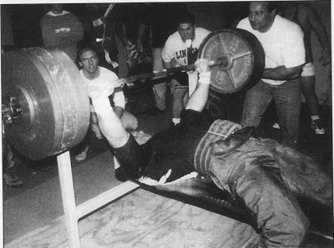

Glenn Buechlein, 1996

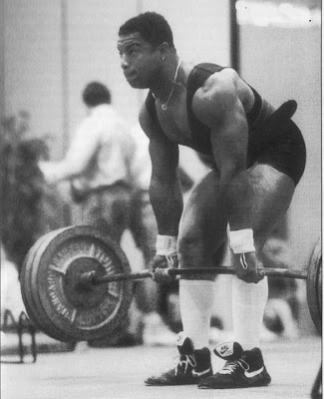

Regular Deadlift, bar approaching knee height

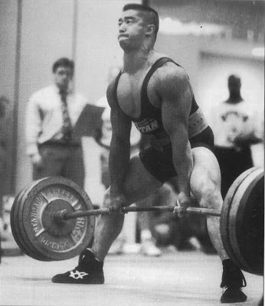

Sumo Deadlift, bar approaching knee height. Note back positions.

3.4 – Training the Shoulder

Everyone knows how to train the shoulders, or so most powerlifters, bodybuilders, and weight trainers think. After all, the classic “hand me down” exercises for shoulder training are there to see in nearly every weight room in the country. Classic pressing movements (military, behind the neck, incline, dumbbell, etc.), as well as dumbbell raises (front, back, etc.) usually constitute the majority of the typical shoulder training “menu” of exercises. The question here is whether shoulder training is as simple as it seems.

If we all know the total story on shoulder training, then logically one would expect there to be no serious problems where shoulder development, shoulder pain, and shoulder injury are concerned. Is this the case today? I would argue strongly that it is quite the contrary. I have begun to realize in recent years that the shoulder is a key problem area. Probably no area requires more thoughtful training and “injury proofing” than the shoulder.

It is amazing to me how many powerlifters and weight trainers whom I’ve talked to have sore or injured shoulders. Typically, the shoulder problems they have are related to a variety of activities, including bench presses, throwing and racquet sports, classic shoulder weight training exercises, etc. It is evident that not many people in or outside powerlifting are really doing the job when it comes to shoulder training. Maybe we all need to do a bit of reevaluation of our classic shoulder training “menu” of exercises after all. Let’s briefly look at what’s involved.

Specifically, for the shoulder complex, there are three bones involved: the scapula, clavicle, and humerus; eight ligaments: coraco-humeral, sterno clavicular, etc.; seven joints: acromio-clavicular, etc.; and believe it or not, 17 muscles, including deltoid, pectoralis major (both sternal and clavicular portions), the four rotator cuff muscles, teres major, latissimus dorsi, biceps, triceps (long head), serratus interior, pectoralis minor, levator scapula, rhomboids, subclavicus, and trapezius. For more information, as always, refer to a good anatomy text.

If is easy to see that the shoulder complex structurally is by far one of the most complicated parts of the body. As a direct result we also have a much greater range of motion possible in the shoulder than in any other joint of the body. Unfortunately, however, this very complex range of motion possible at the shoulder joint makes detailed quantitative biomechanical analysis incredibly difficult. Indeed, methodologically the biomechanical estimation of shoulder muscle activity is so complex that the research that does exist necessarily involves only estimates for the motions and forces involved with the shoulder.

One important point to be made here about the shoulders is that the important muscles and ligaments crossing the shoulder joint are key to shoulder stability. Unlike many other joints of the body (like the hip, for example) the shoulder must heavily rely on muscle and ligament activity rather than skeletal strength for its stability. Therefore, development of the important muscles of the shoulder complex is extremely crucial for preventing problems in activities involving the shoulder. Let’s examine the shoulder musculature more closely.

By now you have no doubt guessed, there is nothing simple about the shoulder muscular system. In fact, there are a number of very unusual features that characterize the muscle action of the shoulder. First of all, there is an unusually high amount of contraction where two or more muscles are contracting simultaneously. Since the shoulder joint lacks stability without muscle action, any muscle that acts to move the arm must work harmoniously with other muscles in order to avoid causing a dislocation. In other words, a large number of shoulder muscles are involved in probably every shoulder motion. Classic references like Inman et al (reference 2) point to this fact.

The second point distinguishing shoulder muscle activity is the number of two-joint muscles. Depending on the position of the arm, scapula, and clavicle, these two-joint muscles will have different effects on shoulder motion. As the position of the bones changes in exercise, for example, muscle activity changes dramatically. This has been demonstrated in several “classic” studies of shoulder biomechanics (for example, references 1 and 2). In other words, small changes in arm of shoulder positions will have significant effect on which shoulder muscles are involved and when and how much these muscles work in a given weight training exercise or a sport motion.

While it is beyond the scope here to try to explore all aspects of the shoulder muscle activity, a few points can be made concerning the deltoids and “rotator cuff” muscles. The three major muscle fiber populations of the deltoid muscle (most often referred to as anterior, lateral, and posterior “heads” of the deltoid) are apparently each capable of contracting fairly independently of the other heads. In other words, bench presses conceivably involve the anterior “head” while the other two heads are largely inactive. It is, however, overly simplistic to view the activity of the deltoids only in this sense (by saying, for example, that front lateral raises work only the anterior head of the deltoid, lateral raises work only the lateral head, etc.). What really happens is much more involved and probably not remotely as clear cut. Many muscles of the shoulder are involved in any shoulder exercise. As for the four “rotator cuff” muscles, the major action of these small muscles is to pull the head of the humerus (the upper arm bone) into the glenoid (the shoulder). In doing this, the deltoid muscle has better leverage and is able to elevate and move the arm more efficiently.

First of all, my personal feeling about shoulder training is that until a more detailed biomechanical study is done and completed on the shoulder, “variety” and “instinct” should be the two key words. By variety I mean that one should experiment with a greater number of exercises for shoulder motion than simply the “classical” menu. One suggestion is to visit a good physical therapist or anyone knowledgeable in shoulder exercises to see the type of exercise they use for shoulder training. Some excellent “non-classical” exercises are available to try out. By “instinct” I mean you should attempt to “tune-in” as much as possible to the body’s response to shoulder movements and exercises. Most top powerlifters have a great knack of evaluating exercises in this manner. This is something we all need to at least try to be aware of in our training.

The results of our research (see Section 3.1) on anterior deltoid involvement during bench pressing showed that:

(1) The anterior deltoid was very heavily involved in all styles of bench pressing, although somewhat more in wide benches;

(2) The timing of peak activity of the anterior deltoid is (along with the other muscles) when the bar is first coming up off the chest in the bench press; and

(3) Increases in bench press weight only cause modest increases in deltoid activity, presumably since this muscle is already so maximally involved.

Let me finish by giving a short list of observations that I hope will serve as “food for thought” regarding shoulder training for the bench press:

(1) I personally am fond of dumbbell presses. This motion seems to activate, at least to some extent, most parts of the deltoid muscle and unquestionably brings into play other parts of the shoulder musculature. Dumbbell presses also reduce the excessive low-back loading associated with normal barbell bench presses;

(2) We have found in our research that the anterior deltoid is massively involved in all types of bench presses. Until we can do further work it is hard to identify exactly which type of bench press works the anterior deltoid most, but the anterior deltoid is unquestionably used a lot in bench presses of all types. It is an interesting question whether the anterior part of the deltoid needs any extra auxiliary work above and beyond bench presses. I tend to think that many powerlifters and bench pressers seriously overtrain it;

(3) I don’t recommend pressing while seated, since the stress in the low back region tends to be higher sitting than when standing;

(4) When and if you experiment with new exercises for the shoulder, use light weights. Don’t be overly ambitious and pack on the weight. The proportional increase is much higher when you try to increase your weight in dumbbell work. Be sure also that you are able to maintain proper motion pattern whenever you add weight;

(5) Machine training for the shoulder region should be treated very cautiously. Generally some of the muscles that stabilize the shoulder probably eliminated in activity (or reduced significantly) since the degrees of freedom are limited by machines. Thus, shoulder exercises when done on machines can often lead to incomplete development of shoulder joint musculature. I strongly recommend that one use primarily free weight motions for a complex region like the shoulder.

Well, I hope that I have provided some food for thought regarding shoulder training. Above all, don’t be afraid to experiment and learn from your own body’s responses to training. Shoulder training, like weight training in general, is anything but “simplistic”. Instead of blindly copying everyone you see, try to “tune-in” to your own body’s responses to exercises. The rewards are well worth it.

References

(1) Deluca, C., Forest, W., “Force analysis of individual muscles acting simultaneously on the shoulder joints during isometric abduction”, Journal of Biomechanics, 6: 385, 1973.

(2) Inman, D, Saunders, J., “Abbott, L., “Observations on the function of the shoulder”. Journal of Bone and Joint Surgery, 26A: No. 1, 1944.

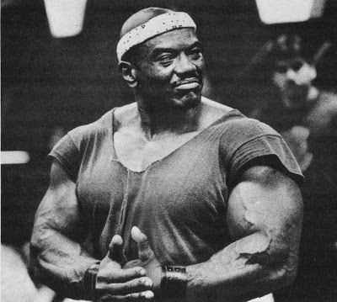

Sergio Oliva

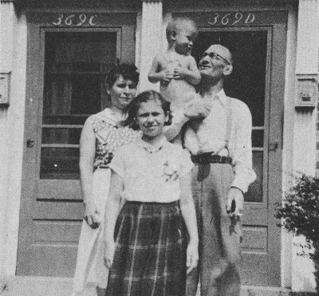

Clevio Massimo

3.5 – Training Associated Muscles

As any great bench presser will undoubtedly tell you, it is crucial to fully develop quite a few other muscles of the upper body in order not so much to improve bench press performance as to prevent potential injuries. While there is no research evidence on the role of these other muscles in bench pressing, it is quite probable that their development is desirable. For example, it is obvious (to me at least) that one should develop ALL the muscles of the shoulder girdle, and in particular, develop the rear shoulder and upper back musculature. Consequently, training these muscles with rear/upper back type movements like supported dumbbell rowing is an important part of “total” bench press training.

I recommend to all bench pressers this type of exercise in, or similar rear shoulder/ upper back movements (for example, shrugs, rear deltoid laterals, high pulls, etc.). In addition, general upper back/latissimus dorsi training is probably of value.

One of the major muscles of the back is the latissimus dorsi (or “lat” for short) and I again refer you to an anatomy text or the hypertrophied back of your choice to refresh your knowledge of this muscle’s location. From an origin that spans a large portion of the lower and middle spine, the muscle inserts at the upper portion of the humerus (upper arm bone). The major roles of the lat are to adduct, internally rotate and extend the humerus. Basically all three of these motions can be seen in a simple chin-up type of action in which the latissimus dorsi is the major muscle involved.

Perhaps the best exercise for this muscle is the classic chin-up/lat pulldown motion. Of studies that I have done to determine the “best” of this class of exercises, several points should be made:

(1) The wider the grip, the greater the lat involvement (???);
(2) The narrower the grip in a pulldown or chin, the more the elbow flexor (biceps, etc.) involvement;
(3) The lower the position of the bar relative to the chest or neck, the greater the lat activity, reaching maximum activity at the lowest position of any exercise. This may be due to the reduced elbow flexor involvement in these positions;
(4) Pulldowns behind the neck involve less latissimus activity than pulldowns to the chest. The outward rotation of the arm needed to pull the bar to the back of the neck makes the pulldown to the neck more of an elbow flexor exercise.

Further, I have found that pulldowns to the chest performed where the where the upper body was inclined back about 30 degrees or so from vertical was perhaps the best movement for eliciting lat involvement. Additional observations include:

(1) Some people pull too much with the arms, and they need to learn to pull using the lats primarily. They should try to bend the arms only when the arms have to bend.
(2) Similarly, using straps is a good way to de-emphasize the elbow flexors and involve the lats more during these pulling motions/
(3) Chin-ups, etc. done on a fixed bar are probably more difficult than pulldowns since the body must be maneuvered around the fixed bar (where the opposite occurs during pulldowns). Also, bodyweight fluctuations from day to day can often complicate progress in chin-ups;
(4) If possible, being able to pull the arms all the way into the sides of the body (usually possible only on machines) or with the one-arm pulldown appears to be a desirable motion for the lats.

The other major movement used for lat development is really more of a combination upper back exercise that develops a lot of other muscles in addition to the lats. I’m talking about bent-rowing and its variations even extending into seated cable pulls (which are quite similar).While doing any of these movements a medium grip is probably desirable for more involvement of all the muscles. However, the major problem of any bent row motion that is unsupported is back aggravation. In a low flexion position the flexion-relaxation phenomenon is invoked and the erector spinae muscle group of the back is largely relaxed. Consequently, the load you are trying to lift plus the weight of your upper body during the bent rowing motion (unsupported) must be borne largely by the ligaments of the low back and the hamstrings. This is why a lot of lifters have back problems coming from bent rowing or seated low cable type pulling movement. It is important to keep the upper body at a higher angle of flexion, or brace the upper body over a high bench and do dumbbell rows.

The elbow flexor muscles (especially the biceps) are also important to develop for an injury-free and successful bench press career. Once again, I’d recommend looking at a good anatomy book if by now you are not too well acquainted with the muscles of the upper arm. First, we have the three flexors of the arm, which “flex” or “curl” up the arm. This classic curling motion is normally thought to be done by only (or at least mainly) the biceps bracchi muscle, but on review of an anatomy text you will learn that the flexor group also consists of two relatively forgotten muscles, the brachialis and the brachioradialis. All three of these muscles are very much involved to varying degrees in the process of curling and all its variations.

The biceps has no attachment on the bone of the upper arm (the humerus), so it is a two-joint muscle originating in the shoulder and inserting on the radius bone of the forearm. The brachialis originates on the humerus about halfway up the upper arm and inserts on the ulna bone of the forearm (which is the “weight bearing” or hinge/connecting bone that connects with the humerus). Finally, the brachioradialis originates from the outside near the forearm, all the way down to the bone above where you wrist bends on the little finger side of the forearm.

These muscles are interestingly individual in a number of ways. Studies have shown that from person to person there is a significant amount of irregular and varied involvement of these muscles during different types of curling movements. Few research studies exist, however, that really show with heavy loads how these muscles are involved in classic weight training arm exercises. There are, however, some valuable insights that should be mentioned.

One of the things that affect the involvement of the three elbow flexors is forearm rotation position. In other words, whether your grip is supinated (palms up), pronated (palms down, as in a reverse curl), or mid/condition (halfway between, as with a parallel grip) there will be a difference in how the flexor muscles are involved. For example, the biceps is most involved when the forearm is in a supinated or mid-position grip, and has considerably less activity when a pronated grip is used. The brachialis muscle (which, by the way, is under your biceps) is the workhorse or “true flexor” of the group. The brachialis is strongly involved regardless of what grip is used, although it should be worked more using pronated grips since the biceps is reflexively inhibited in its activity. Finally, the brachioradialis is most involved when the mid-position is used.

Now, where is someone strongest (that is, where can one exert the most force) during a curl exercise? Well, the strongest overall position in a curl is generally at about 90 degrees or so of flexion (or when the arm is in a mid-curling position). We did some laboratory studies a few years ago at Auburn on regular standard curls versus “preacher” curls, etc. It was found that during a preacher curl you essentially apply maximal loading to your arm flexors at a position somewhere before the 90 degree flexion spot, which depends on the angle of the preacher curl bench. In the standing curl, however, you load the flexors maximally at 90 degrees, which is no doubt better, since this is where, as I previously said, the flexors are also strongest.

What I’m leading to is that in an “optimal” elbow flexor program to help the bench press, regular standing curls should be used. Further, let me say that it also makes sense to vary the grip position used during these standing curls. For example, you could conceivably do a few sets with regular supination grip curls, then continue with a few sets using a mid-position or hammer-curl grip, and then finish off with a few sets of pronated or reverse type curls . . . remembering to reduce the weight using the pronated grip.

When doing heavy regular curls be sure to keep your upper arm stable. Using an arm restraint to help here can be a good training aid. Dumbbells can also be used here, and in fact, advantageously permit the normal supinating (or twisting) role of the biceps to occur on the way up in a curl. In any case, doing regular, heavy biceps training is a logical inclusion in a total bench press program.

The remaining muscles of importance to the bench presser are the forearm muscles in general and in particular the wrist flexors and wrist extensors. Many bench pressers (including, in particular, world class benchers I have known and trained with) have very often experienced forearm and wrist pain/injury. These smaller, weaker muscles must be strengthened to avoid inadvertently being strained during heavy bench press training. Speaking from personal experience also, it is important to all of us to develop the forearm musculature (especially wrist extensors) to “injury-proof” these muscles from the stress of heavy bench pressing. Standard exercises can be done here.

Well, obviously my list of associated muscles could continue on almost endlessly. In fact, training the neck muscles, finger flexors and extensors, etc. are also probably useful. However, if the major muscles discussed here are trained appropriately the chances for successful, injury free bench pressing are certainly enhanced.

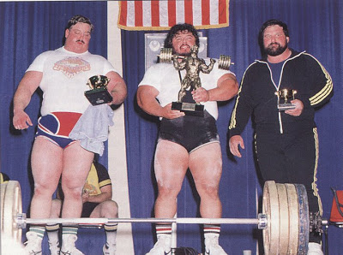

Lee Moran Centered

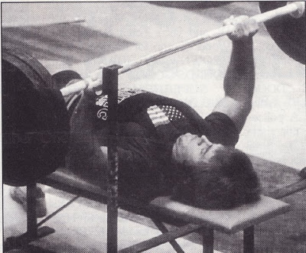

Bud Ravenscroft
Chapter four : Training Ideas for Developing the Bench Press

4.1 – General Philosophy

How should we then train the bench press to maximize performance and minimize injury potential? This remains the million-dollar question and one that may elude us for some time. It is actually probable that there are many training approaches that will produce a better bench press. After all, this is what we see now with all the diversity of programs pumped out in the magazines and books every day. Obviously, people have reached high levels of bench press performance using very different training philosophies and programs. In fact, a glimpse at the research on training muscle shows a similar diversity of “programs that work” (see, for example, Atha’s review [reference 1]).

It seems that bench pressers and scientists alike are both taking the wrong approach to solving this training dilemma. That is, it is just about impossible to ever systematically try every possible training program in the hope that someday the “magic” one will appear that produces 1,000 pound bench presses in six weeks. There are simply too many potential training programs to try. But of course, we still continue to do this a lot and we also still work hard to seek out the results of top lifters in the hope that they’ve stumbled on something we missed. The dangers in this approach are mainly in misdirection with a good chance for people getting into training programs that are really bad and sometimes even dangerous.

Well, there IS an alternative that hopefully you’ve already thought of if you’ve read this far. That is, to take the information on the biomechanics of bench press techniques (as in Chapter 2), add this to the knowledge available on training the key muscles used in the bench press (Chapter 3), and put all this together with the most physiologically valid training philosophy. If nothing else, at least this procedure provides a more research-based approach to training and should logically have more chance for success than simply the “guesswork” that is mainly used today in designing programs. Let’s face it, how much logic do you think is really behind the training programs most people are now in?

Since I’ve already stuck my neck out this far, let me continue and present my philosophy of bench press training (based both on my research and experience):

(1) First, we need to think of the competition-style bench press as the complex sport skill it really is (see Chapter 2). In this lift, technique is VERY important, if not crucial to success. You should think of your competitive bench press as, let’s say, a pole vault or another “complex” sport skill. If you think of it in this way, you’ll quickly come to realize that just as the pole vaulter lifts weights to build the key muscles important to pole vaulting, he also spends a lot of time with a coach working on his techniques. We should do the same with bench press training.
(2) With this first point in mind, an important part of our training time should be spent on training the key muscles of importance to bench pressing (as in Chapter 3). Intelligent training of these muscles, as we’ve previously discussed, should be viewed as “separate” from actual training of our competitive style bench press. Further, the most research and experiential-based physiological training approach should be used as far as sets, reps, intensity, volume, etc. are concerned to best develop these muscles for their roles in the bench press. Additional specialized training can also be used here (for example, to develop strength at the sticking point region) as needed.
(3) The final step is to structure the technique training portion of the total bench press program. Now that more is hopefully understood about bench press techniques (as in Chapter 2), it is time to start coaching the bench press as it should be. Technique assessment, whether it is from simple observation or computerized biomechanical analysis of high-speed (slow motion) films, needs to be done more extensively. After all, technique work is one of the most critical aspects of high-level performance in any sport. In fact, it can be shown that the performances in the 1984 Olympics by U.S. athletes were significantly helped by the biomechanical technique studies done for the coaches and athletes over the previous four years. This is also what the Soviets and Eastern Bloc nations spend considerable efforts in.

Now, let’s spend more time expanding on these ideas and hopefully this bench press training philosophy will become clearer.

References

(1) Atha, J., “Strengthening muscle”, Exercise and Sport Science Reviews, (ed: D.I. Miller, Franklin Press), Vol. 9:1-74, 1981.

4.2 – Optimal Training for Key Bench Press Muscles

First and foremost, keep in mind here that I am saying that you should not rely on bench press training that simply involves doing sets and reps with your competitive style bench press. This is an important departure from most conventional bench press training approaches. Rather, we will use this section to explore how to optimally train the key muscles involved in bench presses. Training of the competitive style bench press will only be done in a “technique development” fashion (to be discussed in the next section).

What I am really saying here is that I am resolving perhaps the biggest bench press training controversy of our time – that is, whether to use singles versus a cycling approach. There are definitely advantages to each, but in my opinion, the singles have value mainly in technique development, and that will be discussed in the next section . . . whereas training individual key muscles is best achieved by using proven cycling (or “periodization”) concepts. What I intend to talk about in the section, then, is how best to develop the key bench press muscles to optimize their role in producing a great bench press.

We have already spent a considerable amount of time in Chapter 3 (see Sections 3.2 through 3.5 in particular) going over the training techniques and exercises that should be used for developing the key bench press muscles. Please refer back to these sections carefully for this information carefully for this information. What we need to talk about here, however, is the WAY in which we train these muscles to develop them most effectively for their role in the bench press.

Based on my experiences over the years it has become evident to me that most lifters believe that somewhere out there is an 8½ x 11 sheet of paper listing the sets, reps, exercises, etc. of the “perfect” training program (for example, do “X” exercise, “Y” sets, and “Z” reps every fortnight until the full moon in June, deloading each third week, but only if the groundhog sees his shadow and Christmas this year falls on either Sunday or its face . . .). They are convinced that someone (whether it is a name powerlifter, bodybuilder, candlestick maker or whatever) knows this super-secret program and their job is to try, by any means possible, to discover it. They are certain this program, if they can just find it, would be the answer to all their bench press prayers. Indeed, they often get so caught up in this quest that they spend an inordinate amount of time, money, vital fluids, etc. trying to uncover this “perfect” workout, and are often preyed upon by sharks swimming the shower-room sewers of public gyms and monkeys swinging with abandon from lat pulldown thingeys.

Wellsir, the joke is unfortunately on them. No fixed workout, no matter how perfect, will work for very long. In fact, any training program that does not effectively and systematically utilize change will eventually lead to overtraining, lack of progress, injury, loss of vital fluids, sharking monkeys and chimping fish. Overtraining is all too common among weight trainers everywhere. The body can be pushed extremely hard, but not for long periods of time without respite. Let’s have a quick look at what’s advised in avoiding overtraining.

In the 1930’s, Hans Selye developed the “General Adaptation Syndrome” that described the way an individual adapted to stress during his lifetime. Expanding on this, Garhammer (see reference 1) has presented the basic concepts of the General Adaptation Syndrome in terms of what happens during training to the powerlifter, weight trainer, or athlete. To quickly summarize, there are three distinct phases of adaptation that a lifter goes through during the course of a weight training cycle:

(1) The first phase (alarm stage) is the initial response to the new weight program. During this first phase there is typically a drop in strength/power levels due to the associated soreness and stiffness that accompany the first few days of any weight program;
(2) The second phase (resistance phase) is where the lifter positively adapts to the weight program and increases his strength/power levels. This is when the program seems to work quite well and progress continues uninterrupted;
(3) The third phase (exhaustion or “overtraining” phase) is where the total stress of the weight training program becomes too much to handle and the lifter’s progress stalls or diminishes. It’s also important to note that other stresses besides the physical stress of the training program can sum to push one into overtraining (such as stresses in work, school, personal life, environment, loss of vital bodily fluids etc.).

Obviously, what we are looking for is a way to avoid the third phase and keep improving our strength/power levels. One of the many ways to do this involves properly incorporating change into the training program. To do this one must change some of the characteristics of any training program, such as VOLUME – the total amount of work done, or INTENSITY – basically how heavy the weights are. The person who first proposed a way to do this was Matveyev in 1961 (see reference 2 for details). His concept of periodization (or cycling, as it is commonly known) is an approach for changing the characteristics of a training program so overtraining can better be avoided and performance can more effectively be increased to optimal levels.

Training volume and intensity should be changed during the course of a training program, generally so that volume begins high (at the start of, let’s say, an eight week cycle) and decreases over the course of the cycle. Intensity, on the other hand, begins low and increases over the same cycle’s duration. The details of this approach are more fully described in reference 2. However, the basic bench press cycle I recommend for developing the key muscles would basically involve 3 weeks of 10 reps, 3 weeks of 5 reps, and 1 week of 2-3 reps before the meet or personal record. Use 3-5 sets per exercise, and up to 10-20 sets per muscle group are acceptable. Beginners in powerlifting or weightlifting appear to require less change in volume and intensity than more advanced lifters with years of training behind them. Furthermore, Stone (personal communication, 1983) has found that the results of a training cycle are greater if the changes in volume and intensity are more abrupt. Many lifters decrease repetitions too gradually during the course of a cycle (for example, going from 10 reps for 3 weeks to 8 reps for 3 weeks, etc. on down towards the meet). Stone’s work indicates that going from 10 rep weeks to 5 reps weeks, then to 3 rep weeks etc. “shocks” the body into greater adaptation than more gradual changes in volume and intensity.

The advanced athlete also needs to add other changes to his program regarding volume and intensity to avoid overtraining. Changing the volume and intensity by varying the loads used WITHIN the week as well as having every 2 to 3 weeks of heavier training followed by a “lighter” week during the cycle are other changes that the advanced lifter should also incorporate in his program. Again, note reference 2 for further details. While space doesn’t permit expanding in detail much further on this point, the main idea here is to change the volume and intensity in the manner I have discussed in your program. By using change to your advantage you will no doubt improve your progress and success on the platform.

Most of the top lifters that I know today use some cycling concepts as discussed above for changing their training volume and intensity during the meet preparation cycle. What I don’t see as often is a change in the biomechanics of the exercises used during their training cycle. In other words, they generally use the same exercises throughout their cycle.

Recent evidence (for example, see reference 3) is beginning to demonstrate the need for periodically changing the exercise movements we use in training. This is, of course, totally consistent with the General Adaptation Syndrome discussed above. Even if we are already changing the volume and intensity as described previously, we still need to avoid doing the same exercise for too long a time. Perhaps the most striking example of this is seen in training on exercise machines. With any machine training situation you have greater repeatability in the exercise due to the mechanical constraints of the movement involved. It’s not surprising that so many people who go on a purely machine-based weight training program will stall progress after 8 to 10 weeks or so. What they need to do (but can’t as easily do with machine training) is to slightly change their muscular involvement through either a change in the exercise or by going to a related but different exercise for the same group of muscles. This, in fact, is one major disadvantage of machines compared to free weights. With weights you have the capacity for diverse change in exercises used, while the exercises on machines are much more dramatically limited.

Obviously, much more biomechanical research needs to be done here in defining how much change is needed and how often it is needed in the exercises used in a training cycle. However, there is no question in my mind how important it is to dramatically change the biomechanics of the exercises you use. Particularly in complex areas of the body like the shoulder joint, variety is indeed the spice of life. The salt and pepper of existence. Being’s nothingness without ‘er. Whether you change the way you do an exercise by altering stance, grip, bar placement, the movement itself, speed of the motion, etc. or periodically use a different exercise altogether, the key is to change. To me, one of the reasons that the bench press is the lift most people have the greatest trouble improving in is that there is usually so little change in the way they bench press. For the most part, when I have taught beginning weight training classes, there are many who actively resist even TRYING one of the many different styles of bench pressing available (mostly, of course, because they won’t be able to lift as much). The best way to improve a stale bench press is to invoke the many possible changes available in this exercise. To do so, as most successful bench pressers have learned, is to improve your bench press significantly. Don’t forget the exercises you use for developing the key muscles involved in the bench press (triceps, deltoids, pectoralis major, etc.) need to be similarly changed periodically as well.

Additional specialized work can be done, in particular, to develop strength in the critical sticking point region. For example, doing isometrics or small range movements with heavy loads in a power rack (set up either based on mechanical analysis of your own sticking point location, or else determined from Figure 8 – for most people about 4-5 inches above the chest and 3-6 inches down from the shoulder). Additionally, using variety in chest development exercises (especially by focusing on different portions of the chest) would help develop strength over the entire region near your bar path and sticking point. Reduced acceleration or paused motions stopped near the sticking point are also potentially useful in developing sticking point strength (and are done a lot by top benchers like Bridges, Macdonald, etc.). Forced repetitions at this sticking point range may also be of some value (ala Arcidi, etc.). I would, however, keep all this work to a minimum, since the shoulder joint (ligaments in particular) can take a beating with this type of training, and needs to be adapted gradually to these higher intensities. Also, these high intensity, specialized motions should probably occur only in the last few weeks of a cycle (during weeks of 5 reps and less), in following the periodization concepts of training.

References

(1) Garhammer, J., “Periodization of strength training for athletes”, Track Technique, 73:2398-2399, 1979.
(2) Stone, M., O’Brien, H., Garhammer, J., McMillan, J., and Rezonek, R., “A theoretical model of strength training”, National Strength and Conditioning Association Journal, Aug/Sept, 36-39, 1982.
(3) Hakkinen, K., and Koni, P.B., “Effect of different combined concentric muscle work regimens on maximal strength development”, Journal of Human Movement Studies, 7:33-44, 1981.

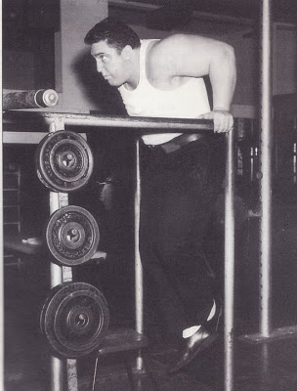

Pat Casey

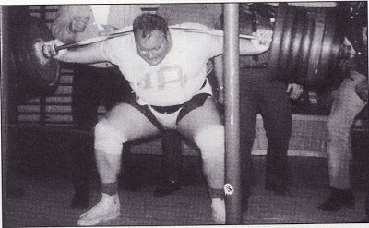

Tom Veller

4.3 – Technique Training for the Bench Press

The most obvious implication of this book is that technique is important in the bench press. The research results discussed in Chapter 2 also question the value of doing multiple repetition sets of competition style bench presses with lighter weights. The shoulder forces aren’t reduced as much as the weigh is, due to the high accelerations typical of lighter high rep sets. Single repetition training that emphasizes learning the correct movement pattern should be more valuable than high repetition training emphasizing totally fatiguing the muscles involved. The bench presser must learn to be continually aware of his technique, and heavier singles are excellent for this purpose. Most great bench pressers have learned this point, as evidenced by the great number that primarily emphasize singles in their bench press training (e.g., Seno, Williams, McDonald, Estep, Bridges, etc.). Basically, the fact that singles worked so well for these great bench pressers is testimony to how important learning better bench press technique is. Further, if one incorporates singles with the periodization training concepts discussed previously (to really develop the key bench press muscles) . . . even better results should occur.

My feeling, again, is that singles should be used primarily for their technique development role in bench pressing. This should probably be the only time your competitive style bench press is done in training. The weights used should be LESS than maximal and increase gradually with your cycle so that a peak is reached in the actual bench press competition. After warmups, a number of singles (perhaps 3-5) should be done with the major emphasis given to perfecting one’s technique. Help coach each other, with the techniques discussed in Chapter 2 serving as a guide. If possible, periodic film analysis of your bench press technique would be invaluable to your progress (such analysis should be widely available soon).

Let me give some sample technique training hints (from Chapter 2):

(1) You can measure the time it takes to lower the bar and compare to the 1.7 to 2.3 seconds typical for elite bench pressers. The important point here is to practice a slow and controlled descent that minimizes acceleration;
(2) High speed films, or even home movies taken periodically of your bench press (perhaps every month of so) are an excellent way to gauge your technique progress over time until digital video becomes commonplace in the unknown future.
(3) Have your training partners watch your elbows on the way up to see that they don’t flare out too soon in the lift;
(4) Attach a pen, felt marker, etc. to the end of the bar so that the bar path is recorded. This can then be compared to the bar paths in Chapter 2, as well used to check for both improvements over time and consistency of the bar path during training sessions. In particular, work on quickly moving the bar horizontally more during that first crucial 4-5 inches off the chest. This is important to practice;
(5) Although I said earlier that you should use the widest legal grip, if you MUST use a narrower grip (this is mainly for those who are smaller in body size or have injuries to the pectoralis major, etc.) you can get a feel for the grip spacing best for you by looking at the technique changes caused by different grip spacings as discussed above in points (2), (3) and (4);
(6) Practice the competitive “pause” by having your partners give you a referee-style clap once the bar touches the chest. However, as discussed in Section 2.12, I would emphasize you use “touch-and-go”, quicker claps here;
(7) Finally, consistently practice all your competition-style bench press techniques as discussed in Chapter 2, so that when the meet does come your bench press style will be an old friend, not a nerve-wracking technique to bear when needed.

Remember, technique training in the bench press is WELL worth the effort, as the top bench pressers of the world have found. In my opinion, it is at least as important as the training of the key individual bench press muscles.

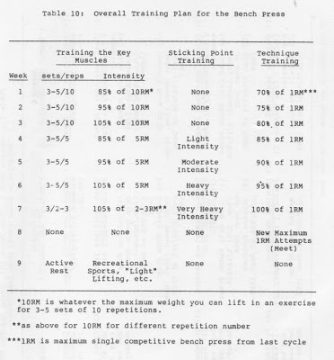

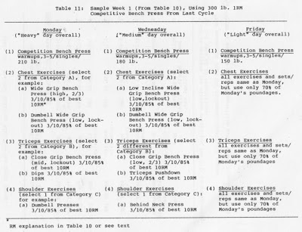

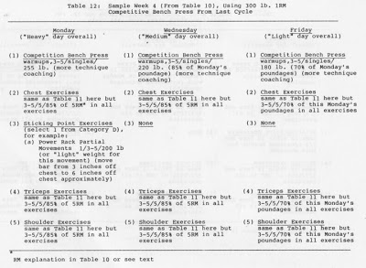

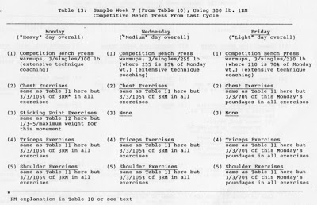

4.4 – A “Total” Bench Press Training Program

Let’s try to put everything together into a generalized bench press training program that can (hopefully!) be used by everyone, at least as a base. We’ll need to incorporate the following factors:
(1) Selection of the exercises that should be used for training the key bench press muscles;
(2) The appropriate use of the periodization concepts in training these muscles;
(3) The addition of specialized sticking point development exercises; and
(4) Technique work with single repetitions in the competitive style bench press (and using technique drills such as those discussed in Section 4.3).

First, I have listed below a “partial” list of the exercises I would recommend for the three “key” bench press muscles (pectoralis major, triceps, and deltoid). I leave the other auxiliary exercises (as in Section 3.5) to the reader’s discretion.

My selection of exercises in each category gives exercise (1) the highest priority, and so one down (e.g., I prefer close grip bench presses over the other forms of triceps exercises, etc.).

A. CHEST EXERCISES:

1.) Wide Grip Bench Press (variations below):

(a) Touch high on chest, lock out fully
(b) Touch high on chest, push up two-thirds only (non-lockout)
(c) Touch mid-chest, lock out fully
(d) Touch mid-chest, push up two-thirds only (non-lockout)
(e) Touch low on chest, lock out fully
(f) Touch low on chest, push up two-thirds only (non-lockout)

2.) Wide Grip Dumbbell Bench Press (same variations as above)

3.) Low Incline Wide Grip Bench Press (same variations as above) – keep incline less than 30 degrees or so above horizontal.

B. TRICEPS EXERCISES:

1.) Close Grip Bench Press (grip with less than shoulder width):

(a) Touch high on chest, lock out fully
(b) Touch mid-chest, lock out fully
(c) Touch low on chest, lock out fully
(d) Lower only one-half way down

2.) Dips (with weight, shoulder width grip, keep body straight and elbows back)

3.) Triceps Pushdowns (grip less than shoulder width, keep elbows into sides, avoid forward lean)

C. SHOULDER EXERCISES:

1.) Dumbbell Presses (standing, palms facing head, shoulder height to overhead range)

2.) Behind Neck Presses (wide grip, lower bar only to about ear-level and push up, standing)

3.) Front Lateral Raises (keep arm in plane midway between front and side arm positions)

The specialized sticking point development exercises I would recommend for building this critical region are similarly:

D. STICKING POINT EXERCISES:

1.) Power Rack Partial Movements (at sticking point region, using competitive style bench press, low reps)

2.) Power Rack Isometric Contraction (at sticking point region, using competitive style bench press, 3-5 seconds duration)

3.) “Slow” Reps (on purpose!) Through Sticking Point Region (reduce acceleration effects, man need less weight, use competitive style bench press)

Now, with the exercises in Categories A, B, C and D in mind, the overall bench press training plan is presented in Tables 10-13. Please not in particular Table 10, which outlines the overall t raining plan. As you will see in this table:

(1) Periodization concepts are used to train the key bench press muscles;
(2) Sticking point training is reserved for the last four weeks of the cycle; and
(3) Technique training increases as the cycle progresses, with singles gradually increasing in weight and more time spent on technique drills, etc. as the meet approaches.

This general plan in Table 10 is one that can more easily be understood by reviewing Tables 11-13. These tables give a more detailed view of how a typical cycle would be structured by providing sample workouts for Week 1 (Table 11), Week 4 (Table 12), and Week 7 (Table 13).

The overall plan in Table 10 provides a base program design that incorporates the major concepts discussed earlier in the book. This sample program can be used for quite some time if:

(1) The exercises (in ALL categories) are changed at the end of each cycle;
(2) The weights used are recalculated based on the new 1 RM, 3 RM, 5 RM, and 10 RM poundages (note: 1 RM means the maximum weight you can lift for your one repetition competitive bench press, but 3-10 reps maxes relate to the maximum weight you can do for MULTIPLE SETS (i.e., 3-5) for that number of repetitions); and
(3) At least once a year (as in “off” season) one or more cycles are performed where emphasis is given only to doing “key” muscle training (i.e., no technique singles or sticking point exercises) and repetitions are kept between 5 and 10. This can be achieved, for example, by first using weeks 1-=6 in Table 10 (as outlined for “key” muscle training only), then using 1 week of active rest (as in Week 9 of Table 10), and starting over with new exercises. This provides more volume, less intensity type “base” work earlier in the season that prepares one for the later (more intense) cycles in the year.

It is recommended that beginners start with the cycle as shown in Table 10, and go through four cycles (36 weeks) before doing two shorter “base” cycles of seven weeks each as outlined above. More advanced lifters can follow the same format, but need to incorporate even more variation into this training plan. This can be achieved by using shorter cycles, varying the exercises even more (perhaps even more within each week), etc. Advanced lifters need more of such variation in order to keep progressing, and it can be incorporated easily. This workout plan is designed to peak you for a competition (or new maximum day) on a Monday. Since this is normally not the case (most meets being on Friday to Sunday), all you have to do during meet week is follow these suggestions:

(1) On Monday of “meet” week 8 follow the same type of “medium” workout you did the last Wednesday (during week 7, see Table 13);
(2) On Wednesday of “meet” week 8 follow the same type of “light” workout you did the previous Friday (during week 7, see Table 13); and
(3) Warm up at the meet on Friday to Sunday just as you have done routinely for your competition singles during the cycle, but in competition use a “comfortably easy” opening attempt, go for your reasonably expectable maximum on your second attempt, and then a “wishful” third attempt. You want to “sneak up” on your attempts and avoid excessively large (and usually foolhardy) poundage jumps. This is the day you’ve been looking forward to, so be smart, watch your technique, take reasonable poundage increments and - ENJOY YOURSELF! You’ve earned that new max.

Final Word

The purpose of this book was to try and bring science and practical experience together in order to provide a better understanding of the bench press. The success of this effort, however, can only be measured by the practical training results experienced by the readers of this book, and by the results of future research on the bench press stimulated by the ideas herein. Hopefully, this book will serve as a worthy starting point for progress in both areas.

I have chosen to use this book as my means of sharing what I know with you. Hopefully, you can take this information and perhaps not only personally benefit, but possibly try to help someone else. It is always unfortunate when people spend great efforts and never achieve the results they want. Make it standard behavior to be of service to those who may not have your experience.

